Власна розробка

УКРАЇНОЗНАВСТВО

збірка текстів,малюнків,завдань

Бєляєва Алевтина Іванівна
учитель-методист англійської мови
Веселівської ЗОШ I-III ступенів
Криворізької районної ради
Дніпропетровської обл.

Цей посібник пропонує збірку цікавого краєзнавчого матеріалу для
використання на уроках англійської мови для обговорення українських
традицій, свят, народних ремесел, одягу, тощо.
Тематика текстів сприяє розвитку соціокультурної компетенції, підви-
щенню зацікавленості учнів у навчанні. А наявність словничка до текстів,
малюнків і різноманітних вправ забезпечують якісне опрацювання
матеріалу.

Carpets
One of the widest kinds of weaving in Ukraine is making carpets or ky-
lyms. Kylyms always decorated the houses, made the warm atmosphere.
Kylyms had an important role in everyday life of Ukrainians and on the holidays
too. It is known that a tribute was often given by kylyms. They were very useful
in trade. Where did people use kylyms? Kylyms were on the walls, on the ben-
ches, on the tables, on a floor, on the sleighs, on the carts, etc... If there were
many kylyms in a house, the host was known as rich. In the poor families ky-
lyms were drawn on the walls.
Kykyms were made of wool, flax, hemp. In Ukraine there are two kinds of
kylyms: long and big. One of the main features of weaving kylyms was a sym-
metric, calm, well-organized composition.
There are regional peculiarities of weaving. For example in Poltavschina
there are kylyms with a plant ornament, the symmetric compositions. In Kyiv-
schyna, Chernigivschyna we shall see the stylized garlands. In Guculschina
there were such kinds of carpets as kots. Kots were grey or white, made of
wool.

MATCH PICTURES WITH THE WORDS:
- an icon; b) a house; c) a pot; d) a trunk; e) kylym;

f) a well; g) a cellar; h) a stove.
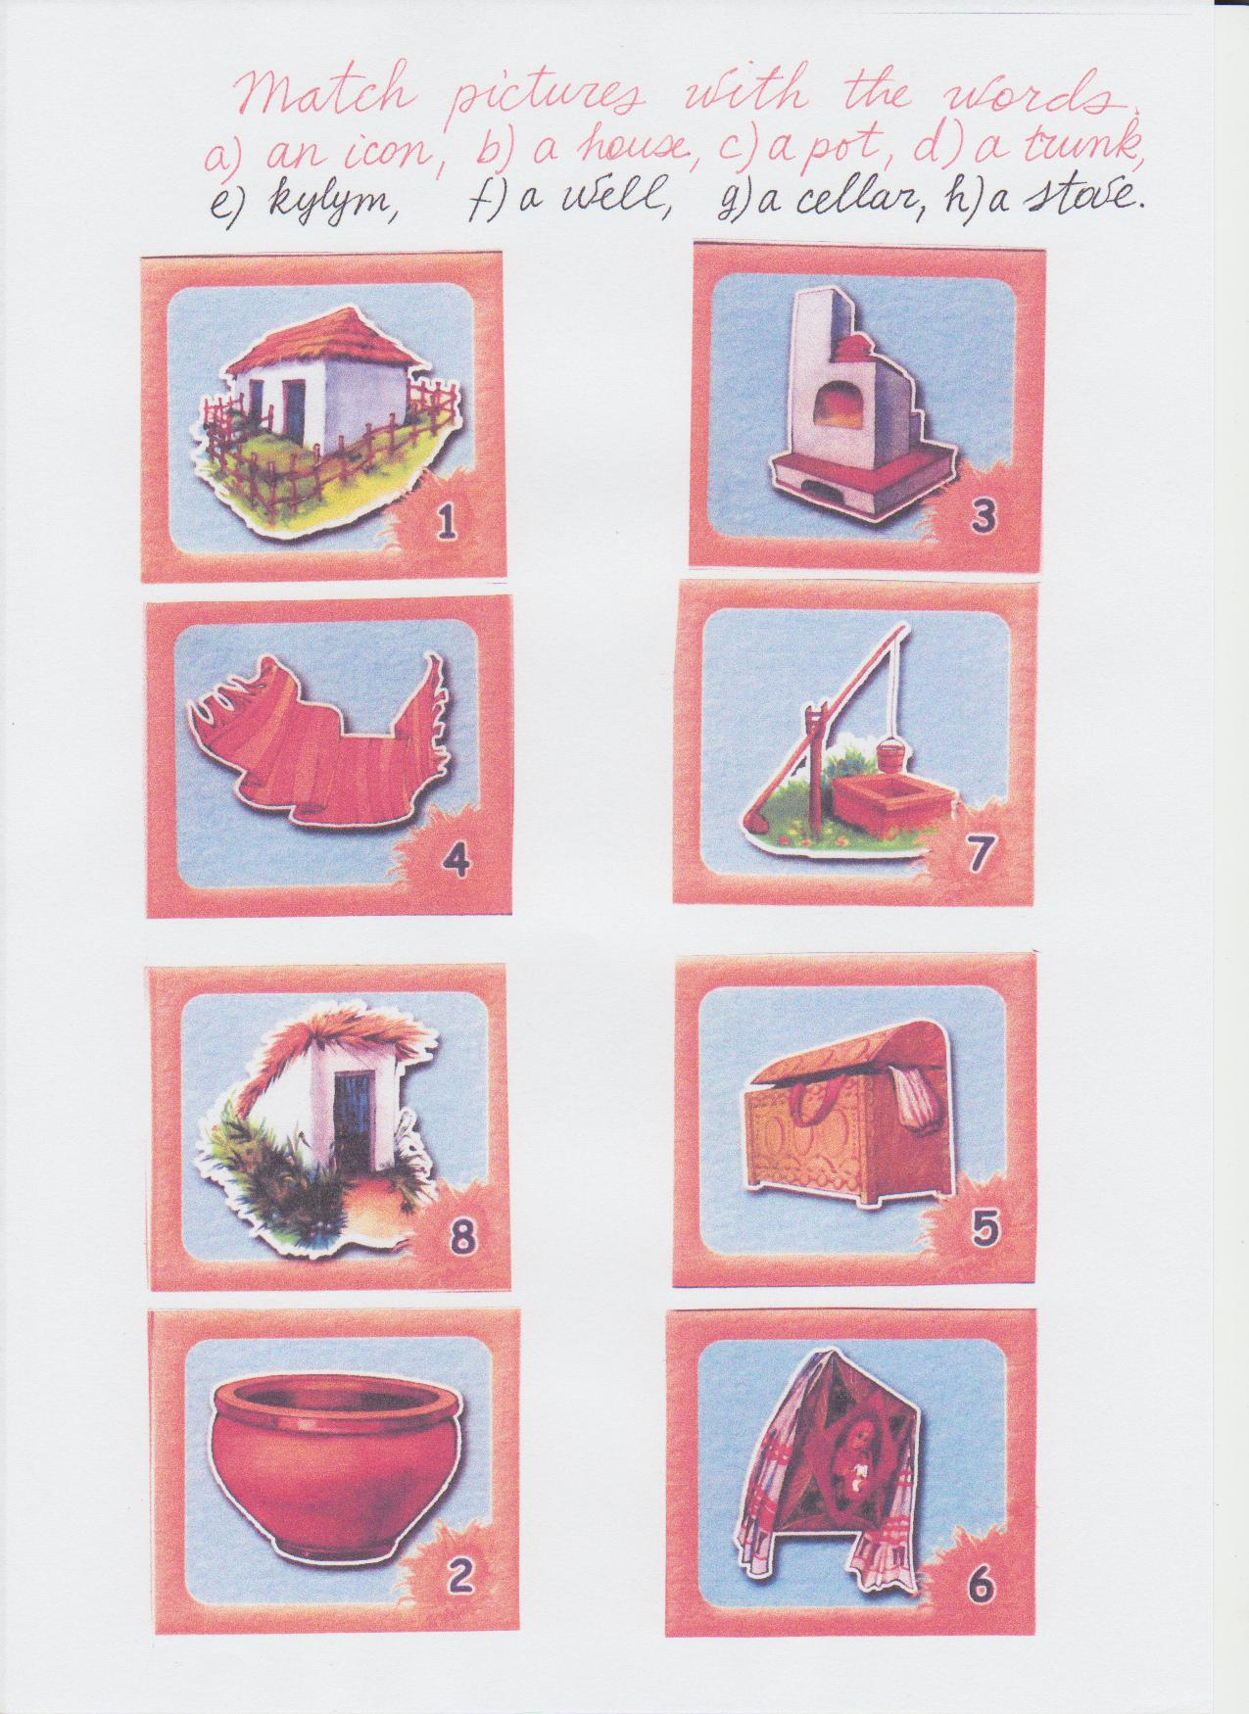

Glossary:
weaving - ткацтво
kylym - килим
tribute - данина
useful - корисний
sleighs - сані
carts - вози
host - господар
draw - малювати
wool - вовна
flax - льон
hemp - конопля
feature - риса
kots - коц (килим)
sheep - вівця

Task 1
Answer the questions (відповідай на запитання)
- What is the widest kind of weaving in Ukraine?

- What did kylyms decorate?

- Were they useful?
4. Where did people put them?
5. Had poor people them?
6. What were they made of?
7. What did you read about the ornaments?
8. What are kots?

Task 2
Put the letters (вставити букви):
W_dest, k_l_m, us_ful, tribute_, sleig_, w_ _l, reg_ _nal, sh_ _p,
o_nament, we_ving, trad_, dec_rate, wa_m, c_ts, c_rts, host_r,
feat_re, peo_le, dra_, re_ _onal, pl_nt, compo_ _tion, exa_ple.

Task 3
Make a plan to the text and retell it (склади план до тексту
і перекажи текст)

Towels (Rushnics)
There is one thing in the Ukrainian house that is very important. What is
it? It is a towel or rushnics. Our people say ”The house without a towel is like a
family without children”. A towel on the wall is our old tradition. A towel is com-
pared with a song. There are different kinds of towels. For example, Styrok is
for plates, benches and a table. Utyrach is for a face and hands. Pokutnyk is for
walls. Vesilnyi is for weddings.
Every Ukrainian girl embroidered. The girls and women embroidered towels
themselves. What did they embroider on the towels? Poppy is a symbol of peo-
ple’s memory. Lily is a symbol of life. The main colors were red, black, green,
yellow. Towels played a great role in the people’s life: a birthed child was put in-
to a towel, bread was put into it when meeting guests. Towels were seen on the
walls, windows, icons. No one important date was held without a towel. In Ukra-
ine there are 100 various embroidering techniques. The oldest technique is so
called «nyz» (низь). One more old technique is setting or fingering.
In the 20th century there appeared embroidering named «cross», a stitch
(стібок), lyshtva.

Glossary :
- thing - річ
- without - без
- compare - порівнювати
- song - пісня
- for example - на приклад
- wedding - весілля
- could - могли, могла
- poppy - мак
- memory - пам’ять
- main - головний
- various - різні
- was held - проводилось
Task 1
What letters are missed?
Me_mory, var_ _us, co_ld, s_ng, th_ _g, com_are, e_ample,
w_ thout, m_in, po_ _y, di_ _erent, to_els, ch_ _dren, s_ng.
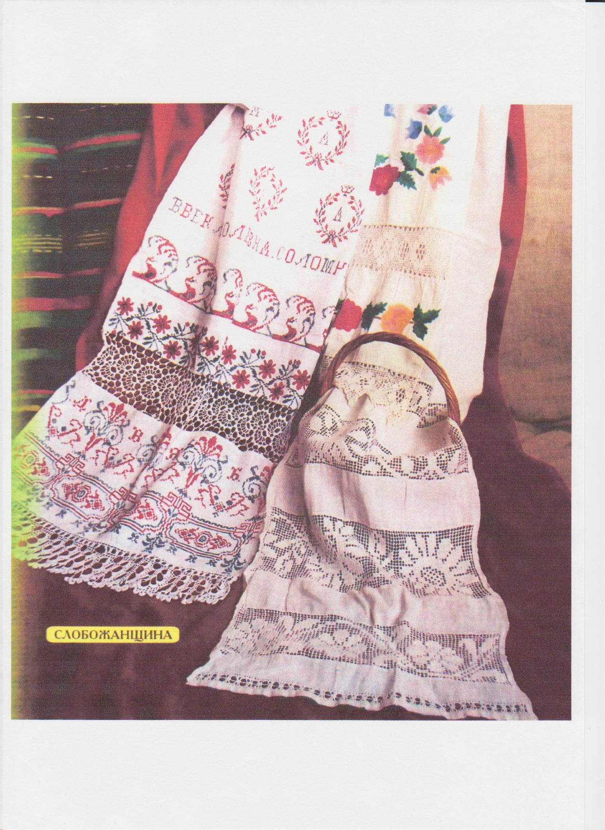

Task 2
What information (a, b, c) is for numbers 1 -5?
- A towel or rushnics.
- Our people say.
- Styrok.
- What can you see on a towel?
- Embroidering technique.
- The oldest technique is so called – nyz.
- A towel or rushnics was always important in the lives of Ukrainians.
- Styrok is a kind of a towel.
- One more old technique is setting.
- We know the technique named- cross.
- Our people say “The house without a towel is like a family without children”.
g) On a towel we can poppies.
h) A towel or rushnics is compared with a song.
i) Poppy is a symbol of people’s memory. Lily is a symbol of life.

Task 3
Are there mistakes?
- There are 2 kinds of towels.
- Not every girl could embroider towels.
- Some people draw towels on the walls.
- Utyrach is for a

Weaving of Reed

Skill of weaving is one of the oldest. In general such things were widely

used. Kids lay in weaved cradles, berries were gathered in baskets, hats were

weaved, a fence so called tyn was weaved too. People used straw, roots, wil-

lows, branches, reeds. In spring or in autumn a host gathered bending roots,

branches. Then a host dried everything, cleaned everything, made the material

bending. Now people do not use things made of branches and straw. You can

see such things in the museums, at the markets.

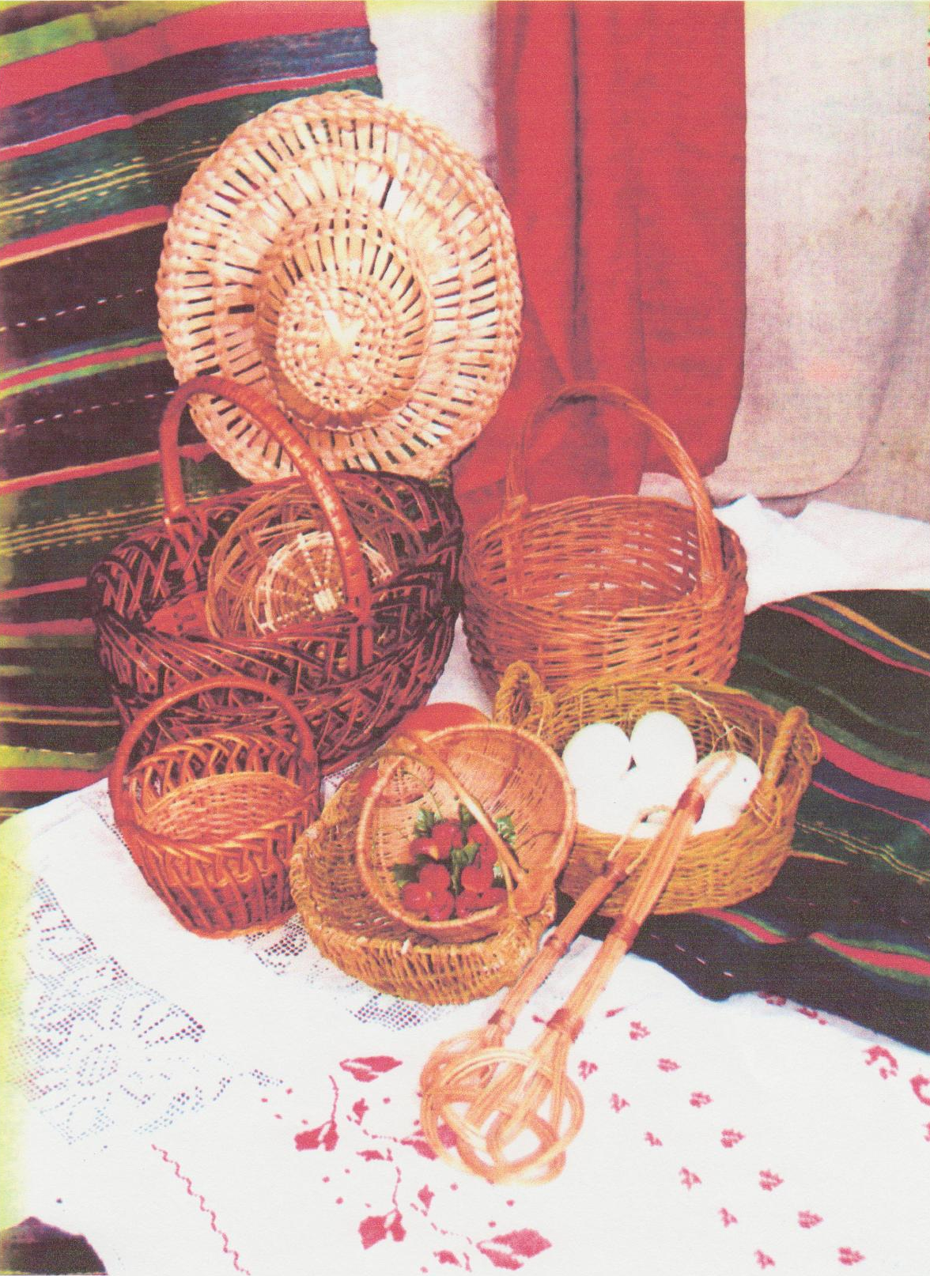
Glossary

Basket - кошик
Skill - майстерність
Used - використовували
Kids - немовлята
Cradle - гойдалка
Berries - ягоди
Gather - збирати
Fence, tyn - тин
Straw - солома
Roots - коріння
Willow - верба
Reed - рогоза
Host - господар

Task 1
Find the best answer to complete the sentences:

- The skill of weaving is__________ .
- one of the oldest;
- one of the youngest;
- old.
- Kids lay in_____________.
- wood, clay cradles;
- weaved cradles;
- weaving cradles.
- Berries_____________ gathered in baskets.
- are;
- was;
- were.
- People use________________.
- trees;
- straw;
- grass.
- A host____________bending roots, branches.
- gathered;
- gathers;
- gather.
6. A host__________everything.
- will dry;
- dried;
- read.
Task 2
Complete the sentences:
- The skill of weaving____________.
- In general such________________.
- Kids lay in_____________________.
- Berries were gathered______________.
- People used straw______________________.
- In spring or autumn________________________.

Easter Eggs

To many people Easter means coming to spring. In spring trees send out new leaves. Birds build their nests and lay out eggs. We color Easter eggs and give them to our relatives and friends.
Pysanky and Krashanky, butter, cheese, sausage are blessed in churches. Krashanky are colored. Krashanky are painted eggs with symbolic signs or without signs. White eggs are used for it. Krashanky is an egg in one color. For example, a red egg means happiness, life, love; a yellow egg means the Moon and the stars. A blue egg means the sky, health; a green egg the harvest, the resurrection of nature.
Krashanky is the simplest egg. Every family, poor and rich paint eggs on Easter. In our days there are special pictures. You take such picture and stick it on an egg. And an egg may have very beautiful ornaments. There is pysanky, scryovanky, malyovanka, krashanky eggs.
Glossary
Easter Пасха
Leaves листя
Send out викидають
Eggs яйця
Bless освячувати
Church церква
Signs знаки
Resurrection воскресіння
Task 1
Discuss the importance of Krashanky in our life.
Task 2
Draw some Krashanky and write - what does your egg
mean?
Task 3
Match the lines:

1. To many people Easter a) new leaves
2. In spring trees send out b) are colored
3. Krashanky c) means spring
4. Krashanky d) happiness
5. A red egg means e) the harvest
6. A green egg means f) is the simplest egg

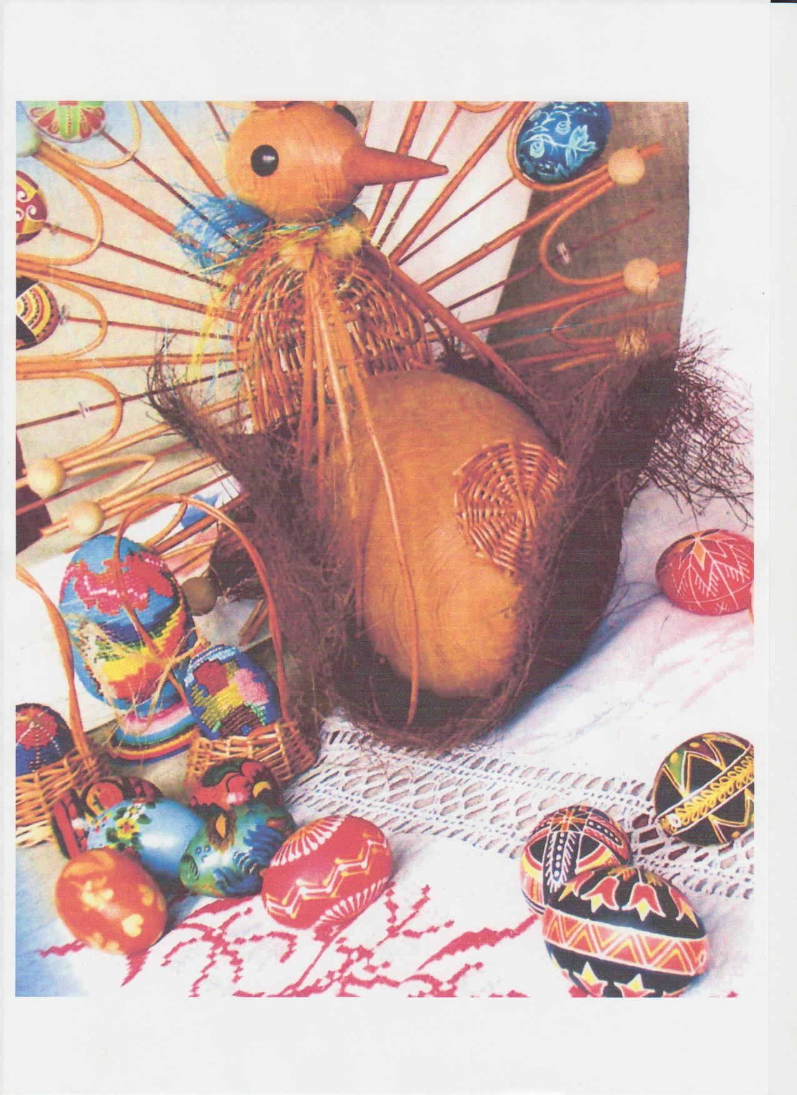

Task 4
Fill in:

Sa _ sage, ch _ _ se, happ _ ness, m _ans, e _ ample, Kra _ _anky,
s _ mbolik, ble _ _, ch _ _ ch, colo_ red, le _ ves, p _ sanka,n _ture, poin _ ed, eg _ ,E _ ster, g _ ve.

Task 5
Correct the mistakes:
- To few people Easter means a great holiday.

- Birds and bears make nests.

- People do not color eggs on Easter.

- Krashanky is a painted egg.

- A red egg means Sun.

- A blue egg means the harvest.

- A green egg means happiness.

- A yellow egg means the Moon.

- On Easter we always bless books, bags, pens, sausage, cheese.
10. We give painted eggs to our animals.

THE UKRAINIAN HOUSE (HATA)
In the corner between the eastern and western windows on the shelves
you can see the house icons. They are decorated by the flowers, the embroi-
dered towels and sometimes by candles. Here one can see a long table, long
benches. As for the furniture there is a bed, a trunk. You may see a cradle if
there is a child in the family. A cradle was a little bed made of wood: an oak or a
willow. A cradle was oval. An embroidered towel was always put over the cra-
dle. A trunk – a big box, it was always closed. Clothes was put into it: blouses,
plakhta, skirts, chaplets, sharovary, trousers, towels, cloths. On the floor there
are carpets (ryadnyny) weaved by women. If the family was rich, there were
embroidered towels everywhere.
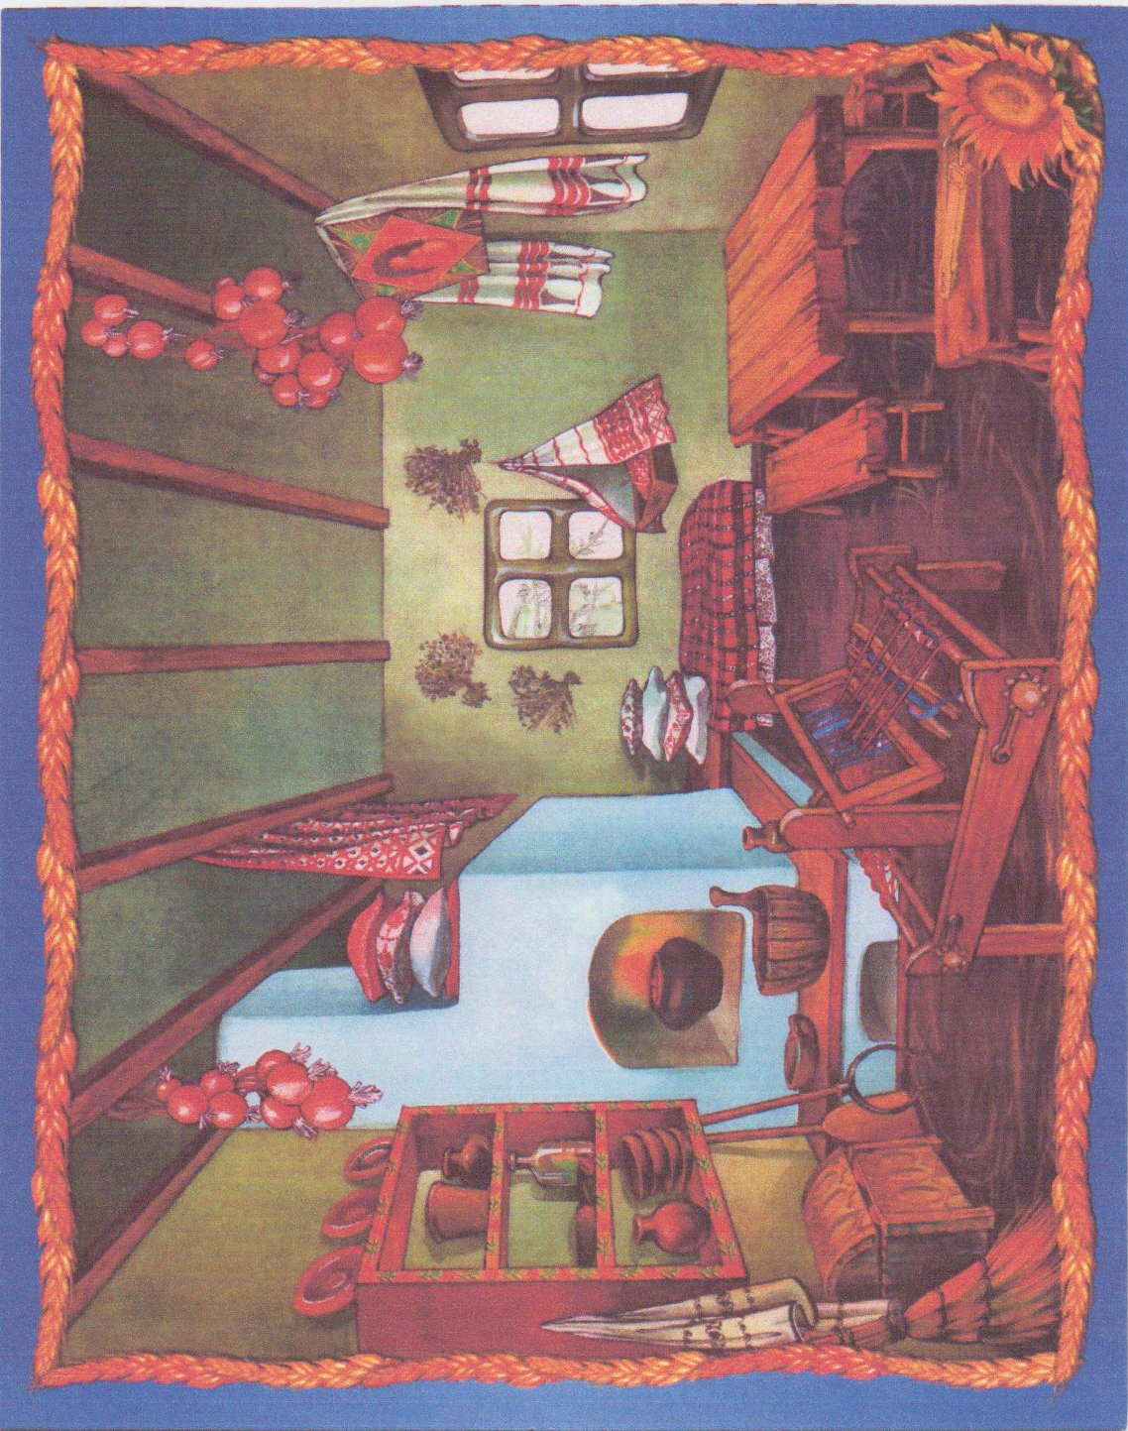
The Ukrainian house (hata)
Task 1
Find the words (11):
a | b | c | d | c | o | r | n | e | r | g | i | j | k | L
e | f | g | e | a | s | t | e | r | n | m | n | o | p | q
v | x | z | u | v | z | h | o | u | s | e | r | s | t | u
w | y | e | d | e | c | o | r | a | t | e | d | v | w | x
f | l | o | w | e | r | s | y | z | a | b | c | d | e | f
u | t | s | r | q | p | o | n | m | e | q | j | i | h | q
w | x | y | z | x | y | f | w | r | n | i | t | u | r | e
a | b | c | d | e | f | j | g | h | i | j | t | r | u | w
k | l | m | n | o | p | q | r | s | t | r | u | n | k | w
t | u | v | w | x | y | w | i | l | l | o | w | z | w | w
e | m | b | r | o | i | d | e | r | e | d | v | c | j | y
c | r | a | d | l | e | v | c | f | f | h | k | j | k | l
c | l | o | t | h | e | s | c | v | b | n | b | m | g | f

Task 2
Answer the questions:
1. What can you on the shelves?
2. How are the icons decorated?
3. The icons are decorated, aren’t they?
4. Can you see a table in the house?
5. How many benches are there?
6. What is a trunk?
7. Was there a wardrobe in the house?
8. Where was a cradle?
9. What was it made of?
10. Who made a cradle?
11. What was over the cradle?
Task 3
Read the dialogue:
P -1 Have you embroidered towels at home?
P -2 Oh, yes, of course. We have some. My grandmother embroidered them
herself. On one of the towels you can see red, yellow, brown birds. On the oth-
er there is the Ukrainian ornament and beautiful flowers. And what about you?
Have you such towels?
P -1 Yes we have. One towel is my aunt’s. She likes to embroider herself. She
can do it, she makes crosses. My mother says that she has seen our grandmo-
ther’s trunk.
P -2 At our school we have the museum. There one can see women’s and
men’ s Ukrainian clothes: caps and hats, sharovary, house things, zapaska.

Task 4
Put the letters in:
H _ self, sha _ _ vary, za _ paska, h _ ve, grandm _ ther, orna _ _-
ment, embro _dered, to _ _ls, th _ngs, flo _ers.

Task 5
Read the text:
It was a poor family. Early in the morning mother baked bread. It was brown
bread. Then she cooked. We had wooden spoons, plates. We sat on a wooden
bench. Our bench was not nice and it was hard. In rich families people had em-
broidered towels. Our beds were wooden too, they were not soft and nice. But
we liked to sleep on our beds, because we worked much and to the end of the
day we were very tired. My parents’ bed was bigger and was not soft too.
In the evening my mother prepared soup or borsch, porridge. We drank milk
because we had a cow. We all liked milk and our cow. My father played on the
psaltery.

Task 6
Retell the text:
PYSANKY
The skill of makings pysanky came to us from the oldest times. There is a
different art of painting pysanky.
In Poltavschyna in the composition of pysanky you see people and ani-
mals, black, dark red, red, green colors.
In Podillya you’ll see red, white, black and violet colors. Here there is ge-
ometric ornament with triangles (трикутники) and wedges.
In Prykarpattya you ‘ll see a small geometric ornament with yellow, black,
red colors.
In Volyn the widest ornament is 40 wedges.
Task 1
Look at the phrases and sentences and write A if you agree,
write D if you disagree.
№ | А | D
1
2
3
4
5

1The skill of making pysanky is young.
2.The art of painting pysanky is the same as krashanky.
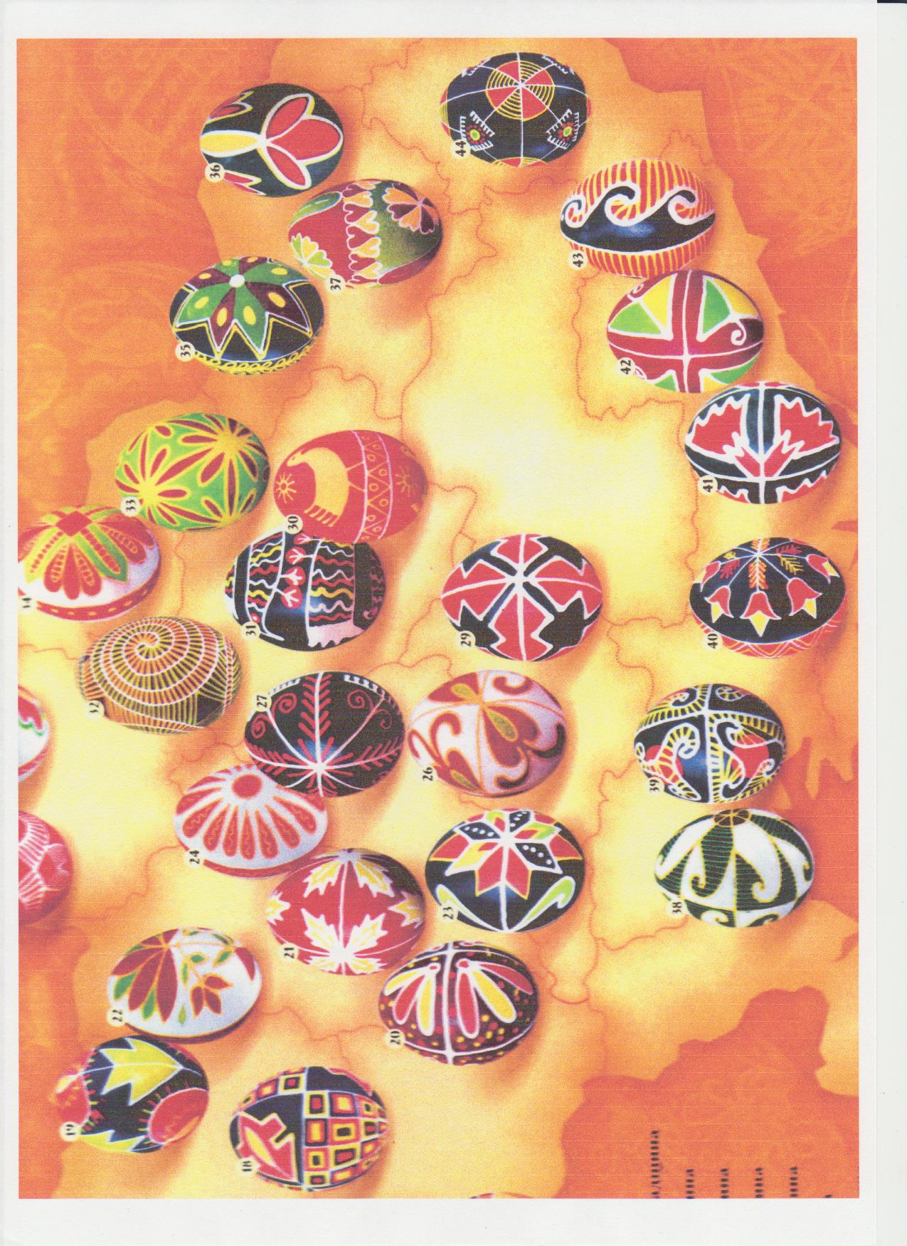

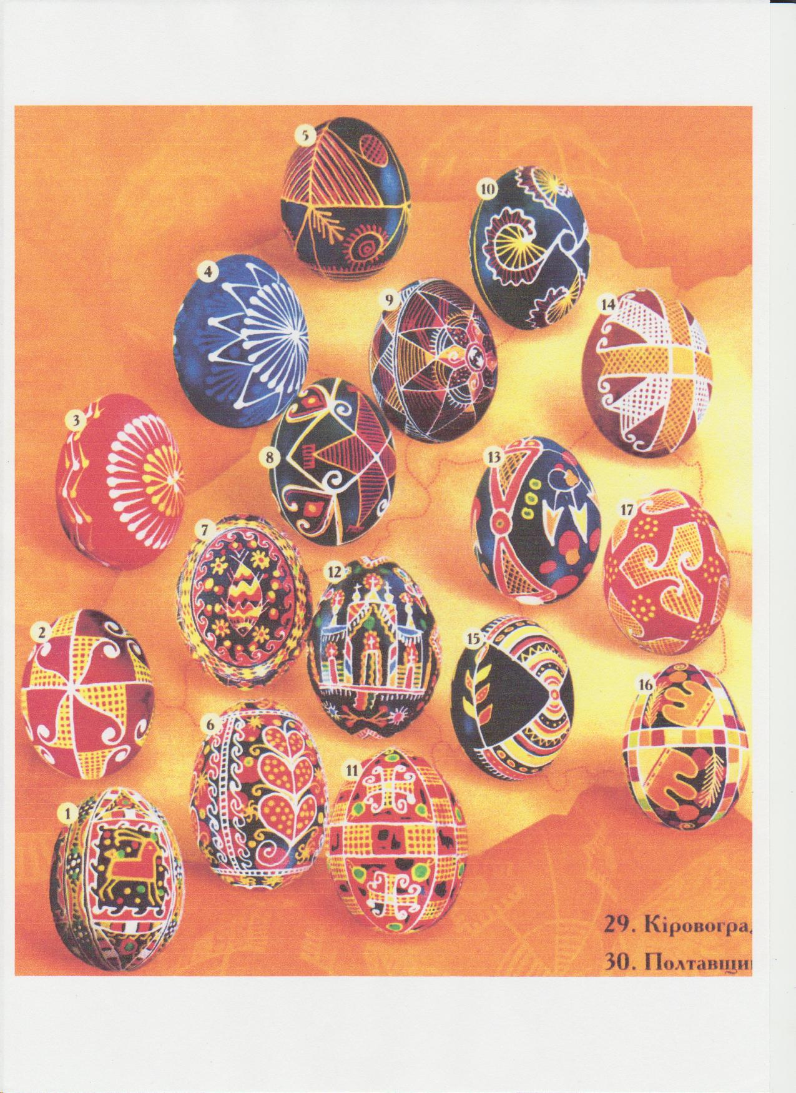
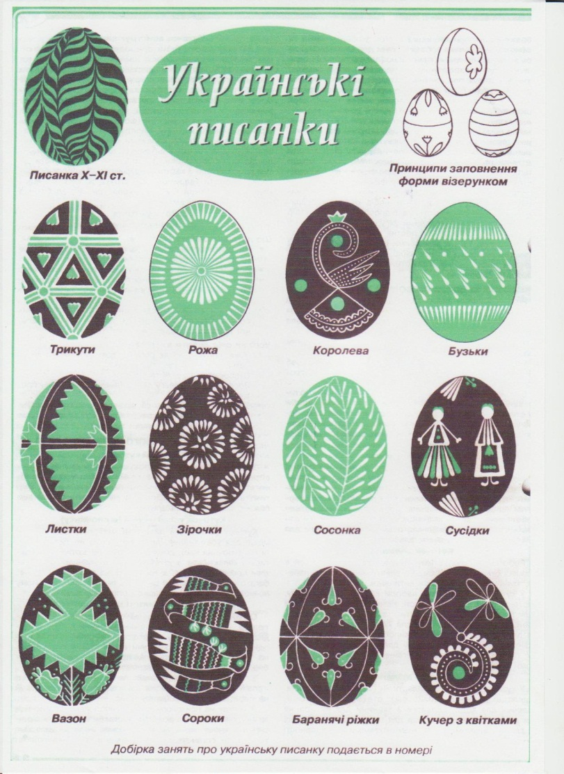
3. In Volyn the widest ornament is 40 wedges.
- In Podillya we’ll see red, green, black colors.
- In Prykarpattya you’ll see a small geometric ornament.

Task 2

Circle the right answer:

- The skill of making pysanky came to us from…….
- the old time;
- the oldest time;
- the earliest time.

- There…… art of painting pysanky.
- is another;
- are another;
- Is different.
- Here there is …….ornament.
a) geometric;
b) oval;
c) round.
4. In Volyn the…….ornament is 40 wedges.
a) widest;
b) beautiful
c) bad.

CERAMIC
The discovery of the magic features of clay met with fire was one of the

important in people’s history. Even the name of first man Adam is translated

as a red clay, soil. The importance of clay in the mankind’s life is difficult to

overate(переоцінювати). Clay was used in building, in making dishes, etc...

Making ceramic things has some stages:

1) Extracting and preparing clay;

2) Making modeling things;

3) Baking.

There is one more invention a very important one is a pottery circle.

Just a pottery circle helped people to make pots and plates very quickly and

in a good form. More beautiful forms were made by potters. Potters became

more professional. People decorated ceramic things by special colored gla-

ze, drew the ornaments by paints.

Ukraine had two waves of pottering art. The first was in the period old rus-

sian princes. The second one belongs to the 17th-19th centuries. Then

there appeared the centers of ceramic production:

- Opishya in Poltavschyna;

- Dybincy in Kyivschina;

- Kolobochyn in Bycovina;

- Bubnivka in Vinnychchyna and others.

The ceramic things were different in different regions. For example in

Kyivschina, Poltavschyna, eastern Podillya there made plant ornaments. In

Opishya one can find the tales’ persons.

In Galychina you’ll see birds on branches, cocks, hens, horses, lions, fish.

Glossary
Discovery - відкриття

Magic - чарівний

Clay - глина

Mankind - людство

Baking - випалювання

Pottery - гончарний

Circle - круг

Paints - краски
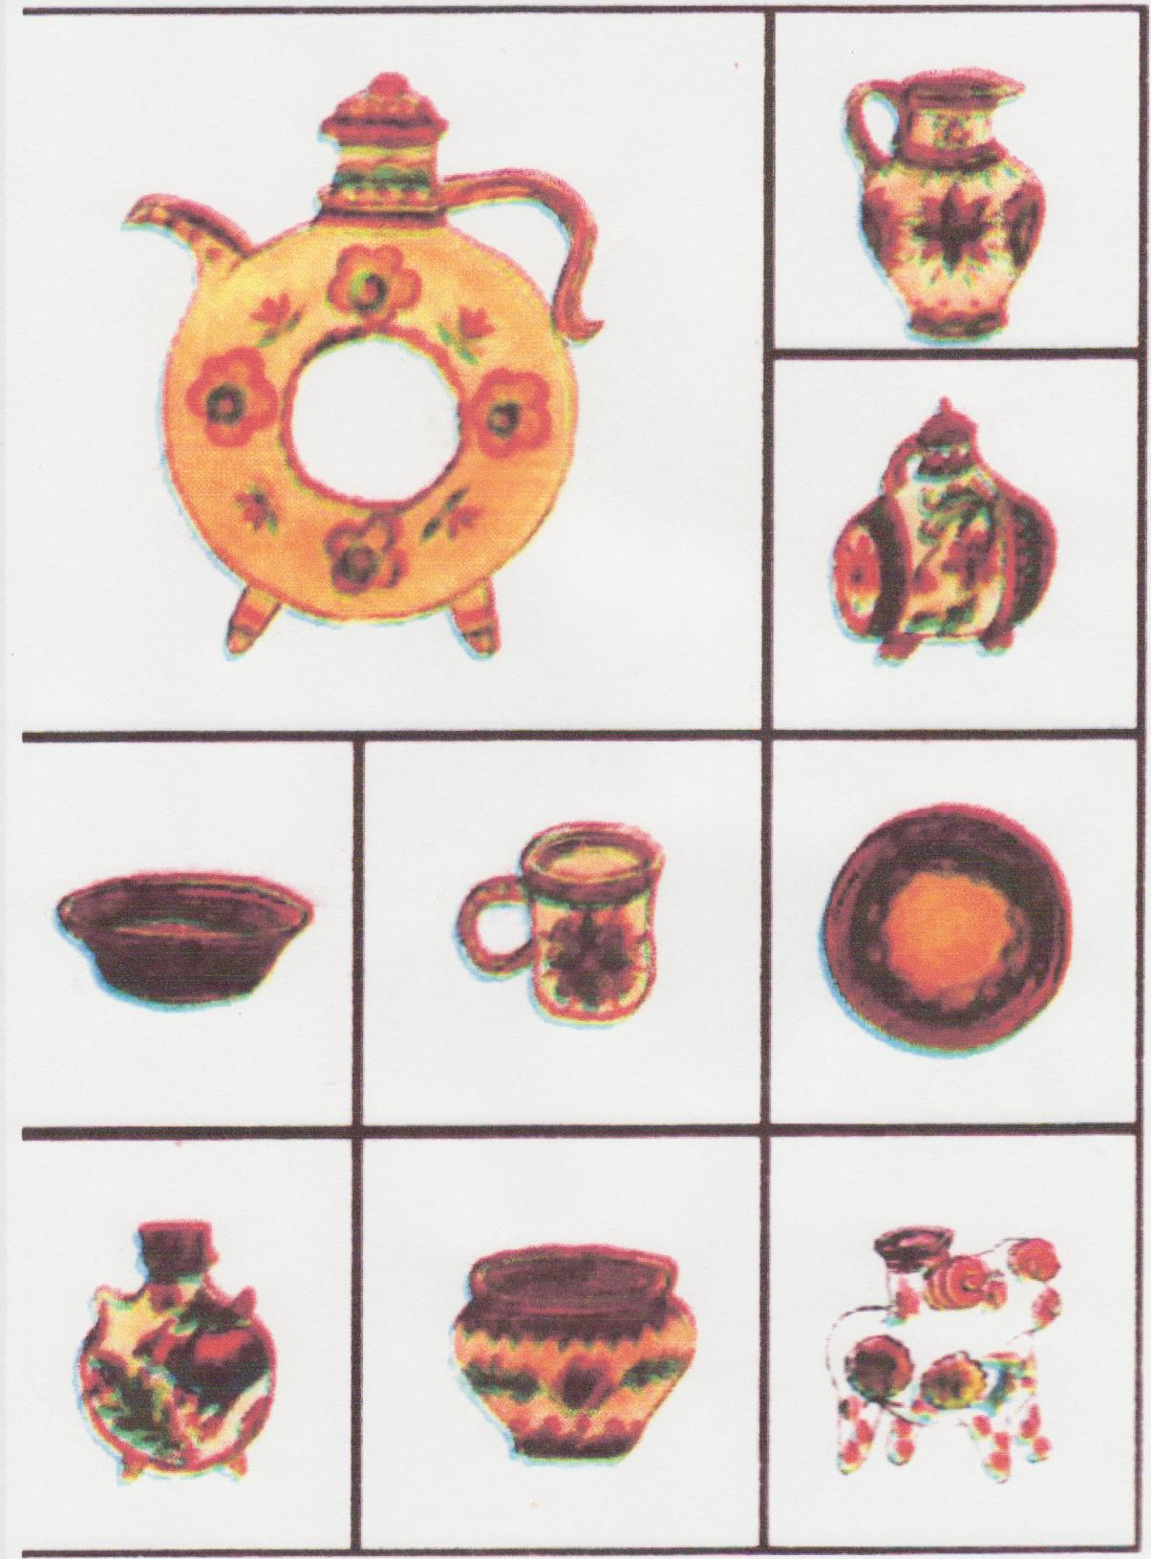
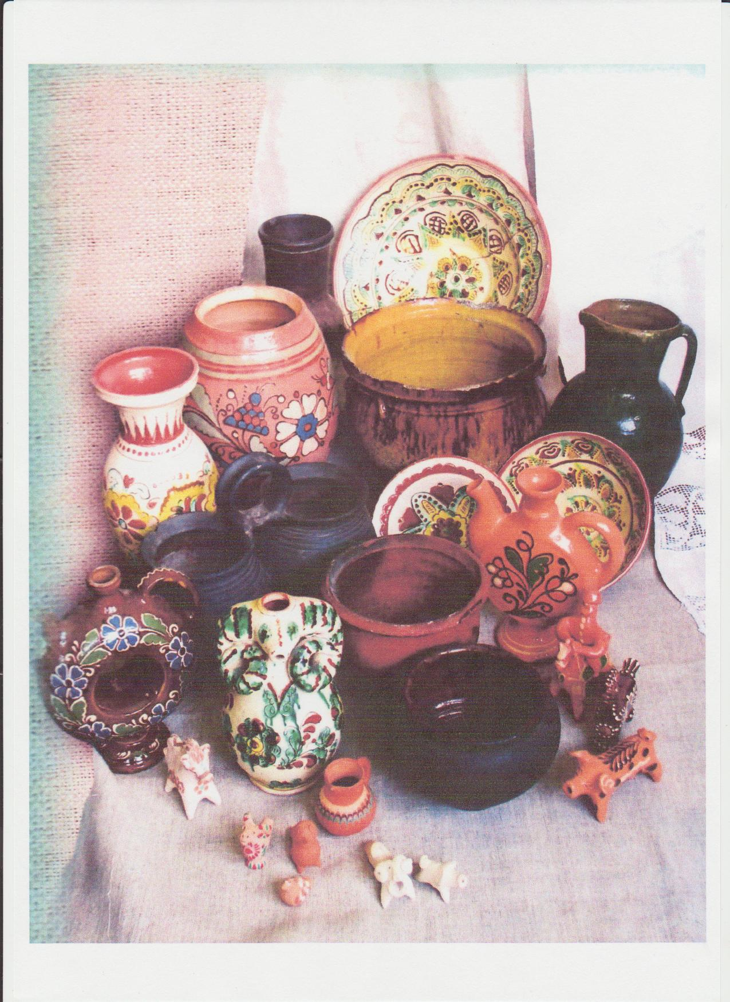
Clay - глина
Mankind - людство
Extracting - добування
Baking - випалювання
Invention - винахід
Pottery - гончарний
Circle - круг
Glaze - глазур
Paints - краски
Princes - князі
Centuries - століття

FIND THE WORDS
Task 1
A | B | C | E | R | A | M | I | C | A | C | D
Z | W | B | U | I | L | D | I | N | G | X | P
E | A | D | M | A | G | I | C | V | B | N | M
S | P | O | T | T | E | R | Y | B | V | C | X
O | C | I | R | C | L | E | E | R | T | Y | U
S | I | N | V | E | N | T | I | O | N | Z | X
J | G | L | A | S | E | T | Y | U | I | O | P
N | D | E | C | O | R | A | T | E | D | G | H
P | R | O | F | E | S | S | I | O | N | A | L
O | R | N | A | M | E | N | T | S | D | F | G
C | D | I | S | H | Q | W | E | R | T | Y | U
F T

Task 2
Are the statements true or false?

1. The discovery of clay was very important.
2. Making ceramic things had some stage3.Clay was not used in build
ing.
3. The ceramic things were different in different regions.

4. Ukraine had three ways of pottering art.

5 Ukraine had two ways of pottering art.

Task 3
Put the questions to the following answer:
- What__________________________________________________?
The discovery of the magic features of clay was one of the important.
- How is_________________________________________________?
Adam is translated as a red clay, soil.
- Was___________________________________________________?
Clay was used in building.
- How many___________________________________________?
Making ceramic things has many stages.
- What is one more __________________________________?
There is one more invention, a very important one, a pottery circle.
- Did___________________________________________________?
Yes, it did. A circle helped people to make pots and plates very quickly.

WEAVING
Weaving is known on the territory of Ukraine long ago. It is evident that the

fabrics are not saved but archeologists have found weaving joiner’s benches,

spindles of the period of the trypil culture. At the end of the 20th century weav-

ing – one of the widest skills in villages. Villages made all the fabrics, clothes

themselves in their own houses. When did women do cloth? In winter for a

long, long time families made fabrics, clothes themselves. Then the best mas-

ters made fabrics for another people for money.

By and by weaving was done in towns. Little and big shops were opened.

Traditionally the process of weaving has some stages:
- Spinning of threads.
- Coloring of threads with the help of plant or mineral colors.
- Weaving on weaving machines.
We are used that fabrics are made at the big factories when electric is
used. You see how difficult it was to weave, when there were no such modern
machines.
Coloring of cylyms, rushnics, towels was various. Every region had its pat-
tern. Nowdays there are two kinds of weaving: one that gives a striped picture
(chovnykovyі). The other when the picture appears with different geometrical
elements joined together (fingering).

Glossary
Evident - зрозуміло
Fabrics - тканина
Joiner’s bench - верстат
Spindle - веретено
Skill - ремесло
Themselves - самі
The best - краще
Master - майстер
Workshop - майстерня
Spinning - прядіння
Threads - нитки
Striped - смугастий

Task 1
Put together the jumbled word pieces:

1 evi ter
2 fab dent
3 mas ped
4 stri ads
5 thre rics
6 spin ning
7 work ch
8 ski selves
9 ben ll
10 them shops

Task 2
Put the letters in:
Vill _ ge, co_ _ur, fa _tor _es, spi _ dles, w _ aving, re _ ion, v _ rious.
Task 3

Find the mistakes and read correctly:
- Weaving is known not long ago.
- At the end of the 20th century weaving was one of the widest skills.
- For a long time families made fabrics themselves.
- Coloring kylyms was the same everywhere.
- Women made fabrics in summer.
- It was not difficult to weave.
- Archeologists could not find any weaving machines.
Task 4
Form the sentences:

Weaving, on the territory, is known, long ago, of Ukraine.
Traditionally, has, weaving, some stages, the process.
You, see, to weave, it, was, difficult.
Coloring, towels, of, various, was.

For, families, a long time, fabrics, made, themselves.
By and by, in, weaving, towns, was done.
When, women, do, did, colored, clothes? The best, then, masters, for,

people, another, fabrics, made.

UKRAINIAN FOLK TOYS
In the picture you see a horse, a bird, a deer. Such funny, merry,
various, holiday and everyday toys were made from clay, straw, wood. A wood
toy is may be the oldest. At first it was a usual branch like a man or an animal.
Then there appeared instruments for working up wood. The centers of making
wooden toys: dishes, whistles, sopilkas, pistols, dolls are the west of Ukraine.
A straw doll-winder (солом’яна лялька-мотанка) is well-known world. It is made of straw, grass, reed, which are bended in half, then are tired in three places. So that a head and body is formed. Then it is dressed. Such dolls could be made of threads. Knot’s doll(лялька - жованка або вузлова). A woman took a piece of bread, chewed it and put into a cloth, tied as a knot. It was a head. Then a doll was dressed. On the head there was a scarf. A dress was made of pieces of cloths. You see an apron on a doll too. The chewed bread and a cross on the face fulfilled the role of a guard (оберег).
Clay’s dolls
Clay’s dolls were found by archeologists, belonged to Trypic culture.
Scientists think that all whistles (wooden and clay) were ritual, with help
awakened the yarylo-sun in spring. There were eatable toys which one
could eat.
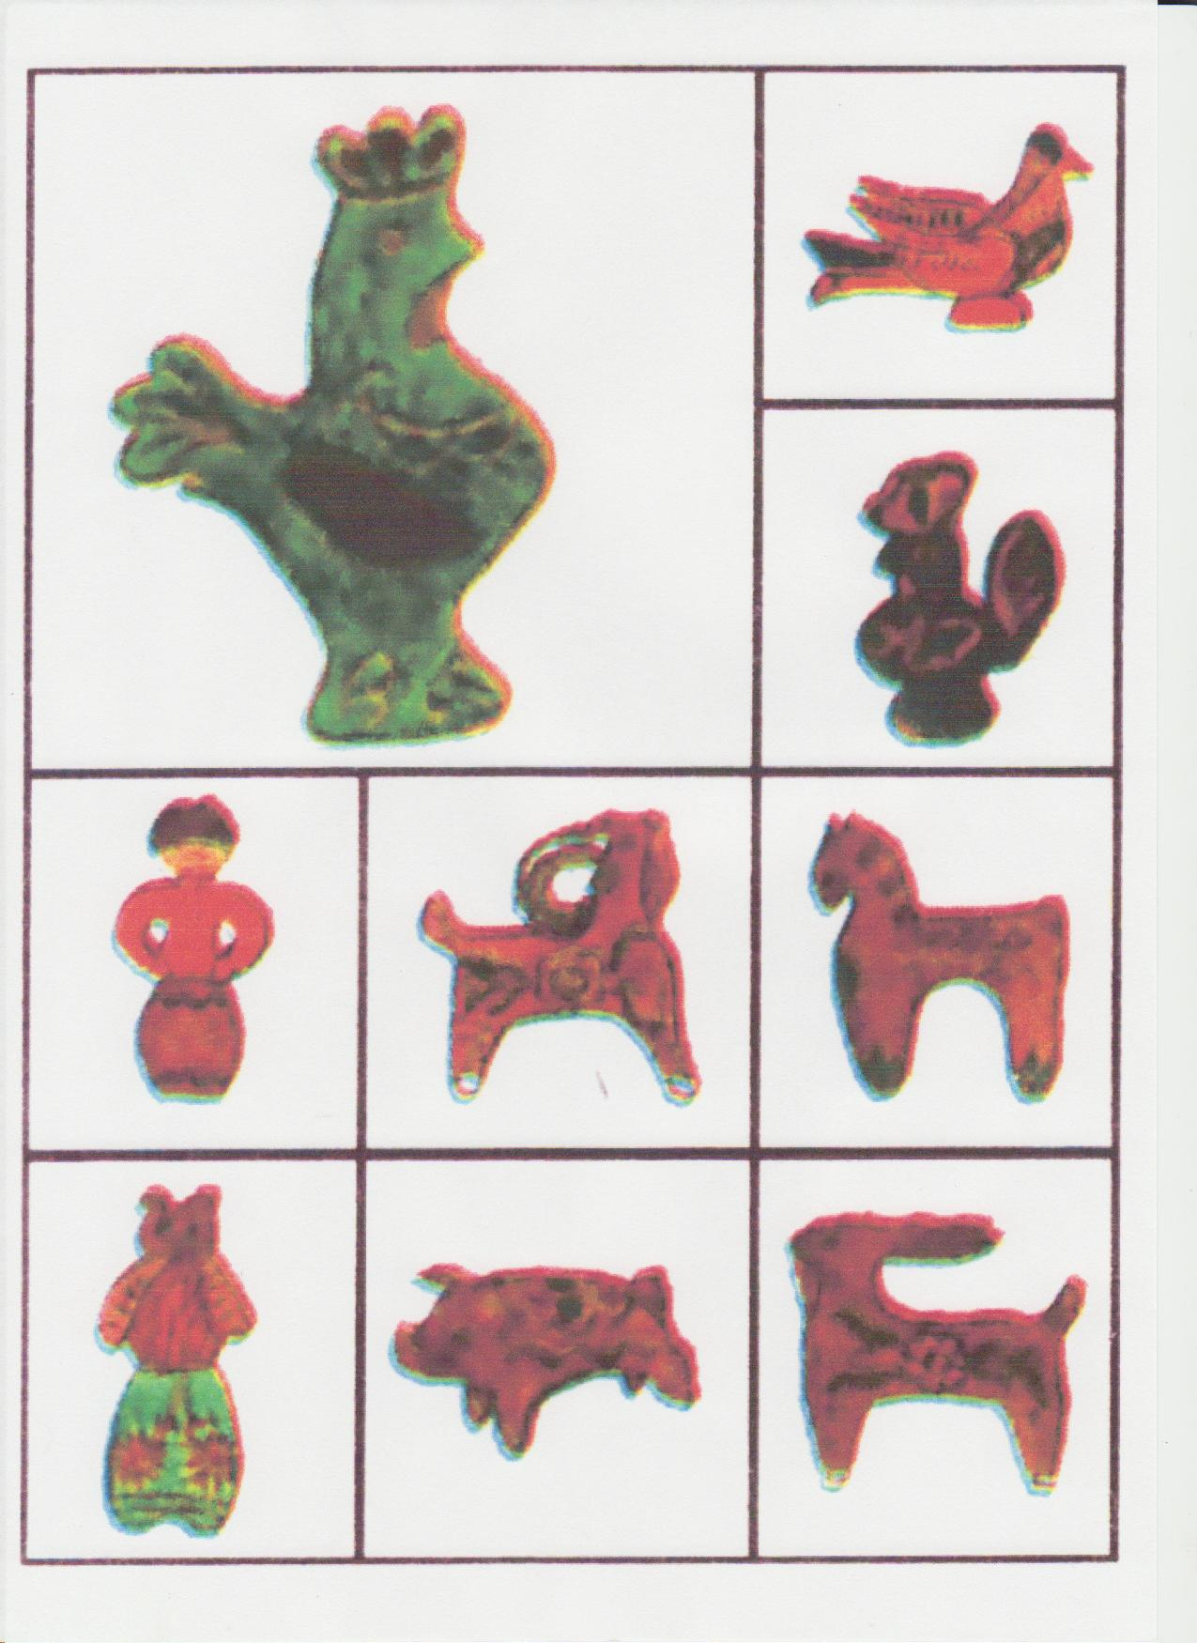
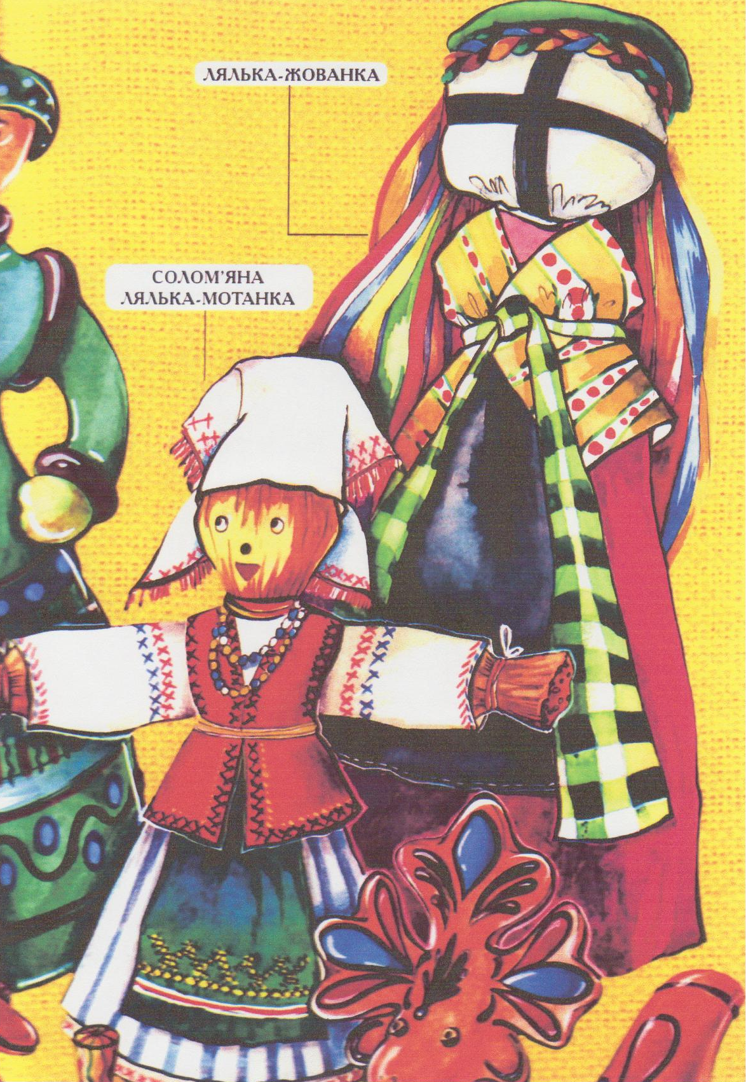
Glossary
Deer – олень clay - глина
Various - різні straw - солома
Whistle - свистка bend - гнути
Threads - нитки cloth - тканина
Chew - жувати scarf - хустка
Apron - фартух eat - їсти
Ritual - ритуальний guard - оберег
Piece - шматок
Task 1
Answer the questions.
- What toys do you see in the picture?
- What were they made of?
- What toy is the oldest?
- What way made of clay?
- What doll is well- known?
- What is a knot’s doll made?
- How is a knot’s doll made?
- Why is a knot’s doll considered a usual guard?
- Were there eatable toys, weren’t they?

Task 2
Choose the right variant:
- In the picture you see …
              - Books c. Pens
              - Toys
            - Such funny, merry, various toys…
Of clay, straw, wood.
              - Was made c. Will be done
              - Were made
            - A wood toy is may be the…
              - Oldest c. Older
              - Old
            - … is well- known in the world.
              - A straw winder c. A straw- doll- winder
UKRAINIAN NATIONAL WOMEN’S CLOTHES

In general Ukrainian national women’s clothes is the on all the territory
but there are differences, regional ones.
The typical clothes in the west of Ukraine was a cloth without sleeves -
keptar or curkan, was decorated by strings, tassels, applications.
The women’s blouse is the oldest piece of clothes of our foremothers.
It was sewn of white linen. It should be mentioned that they embroidered it too.
A blouse was put on a body.
Opynka(опинка) is an original women’s belting cloth, a piece of fabric. Zapaska. Women wore it on a working day. It is a piece of fabric put on a long,
white blouse. Opynka and Zapaska was a typical cloth in the west – black, red
and white.
Plakhta was of checked cloth, a holiday cloth made of wool. It consists
of two towels (gryvok), sewed half together.
Poperednytsya (a skirt) appeared in Ukraine later on.

Dukaty - women’s adornment on the neck of coins instead of beads.
Lychaky – weaved shoes.
Boots – sewed of skin were like men’s boots.
Postoly (khodaky) – were made of a soft thick skin.
Kapchury - wool stockings.
Ochipok (chepec, chepchyc) - a head attire of a married woman.

Glossary
General - загальний
The same - той самий
Differences - різниця
Sleeves - рукава
Strings - шнури
Blouse - сорочка
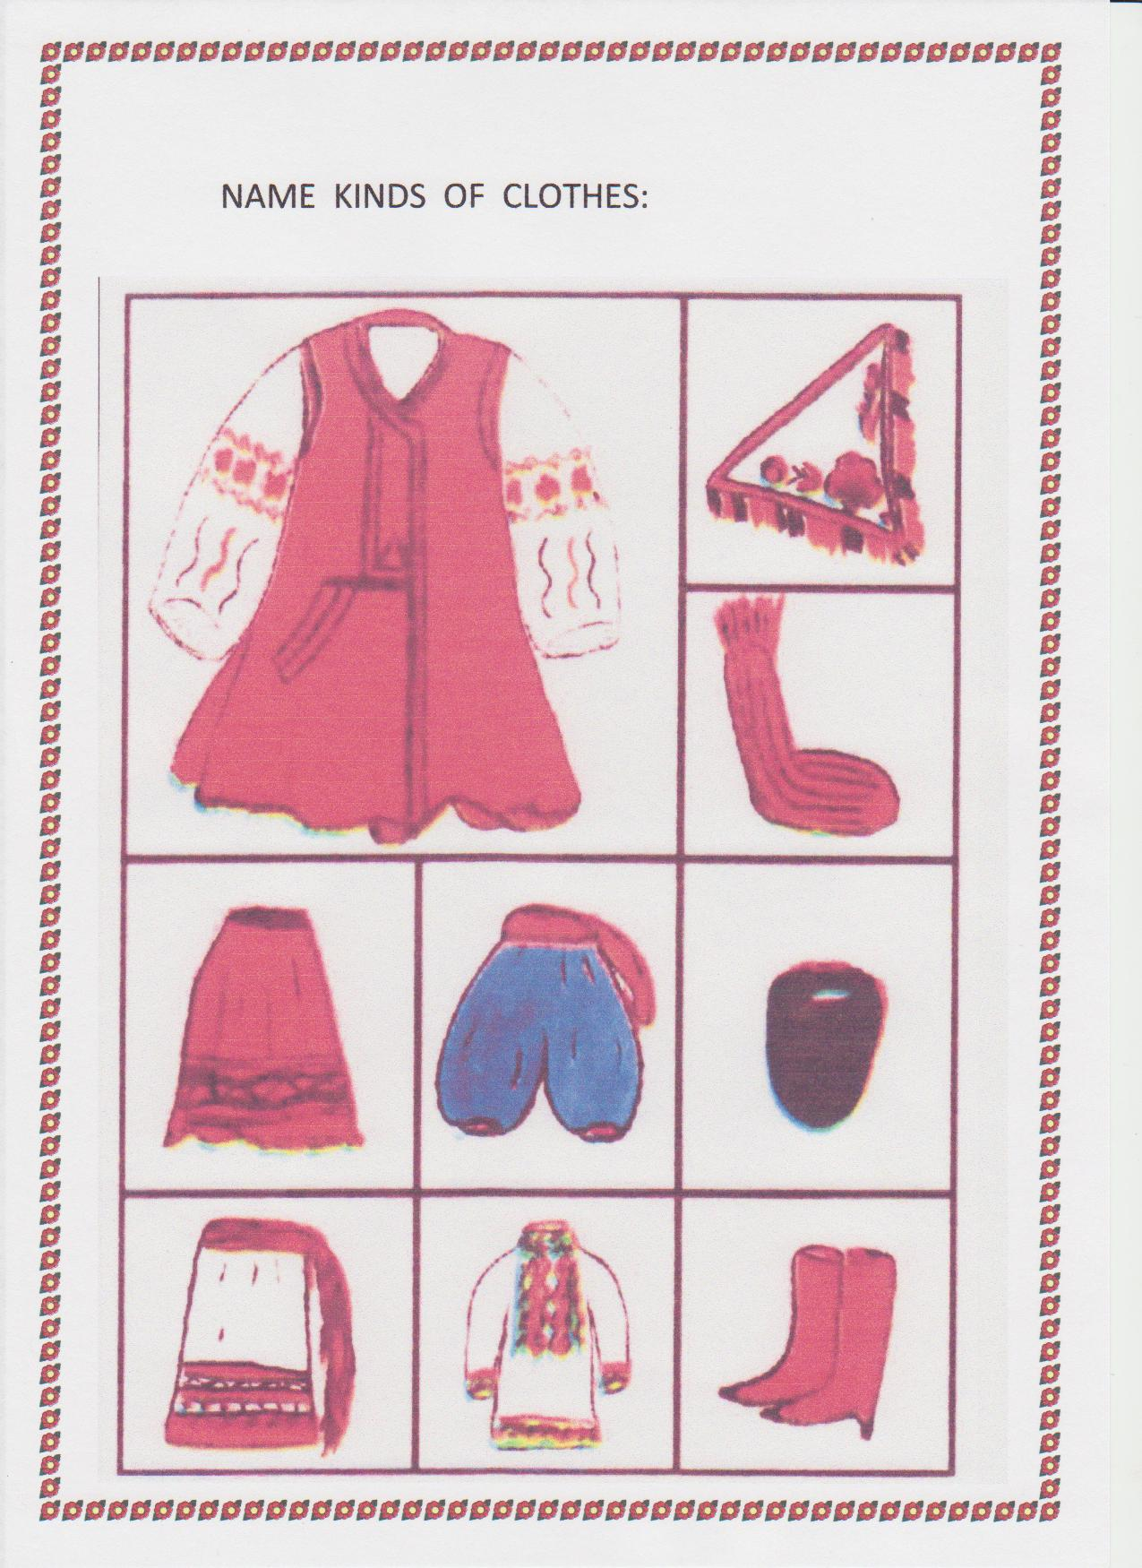
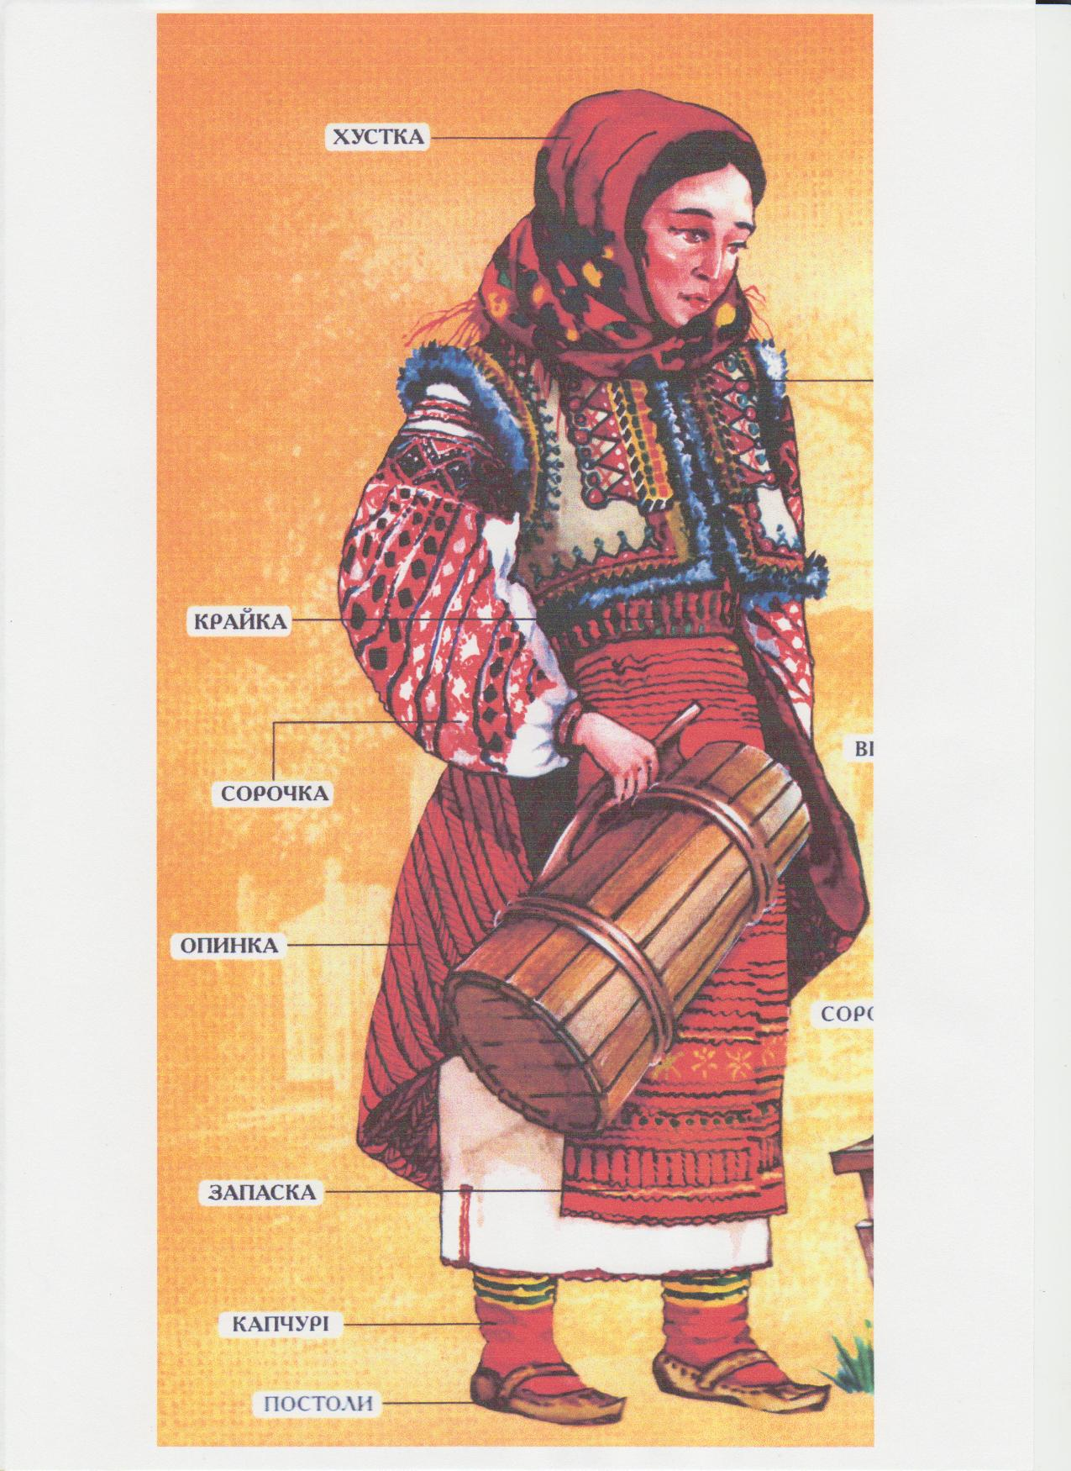

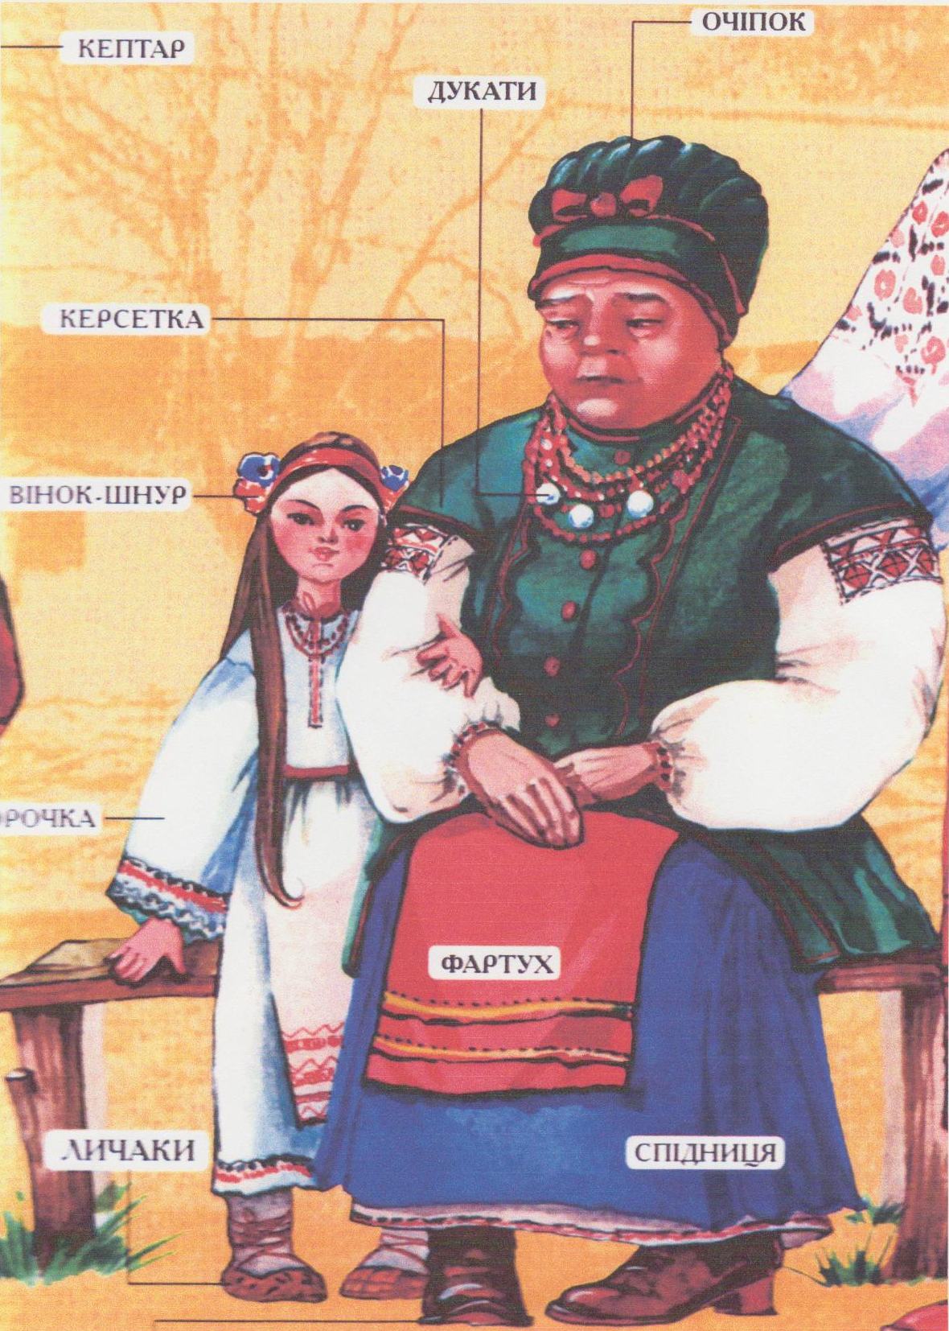
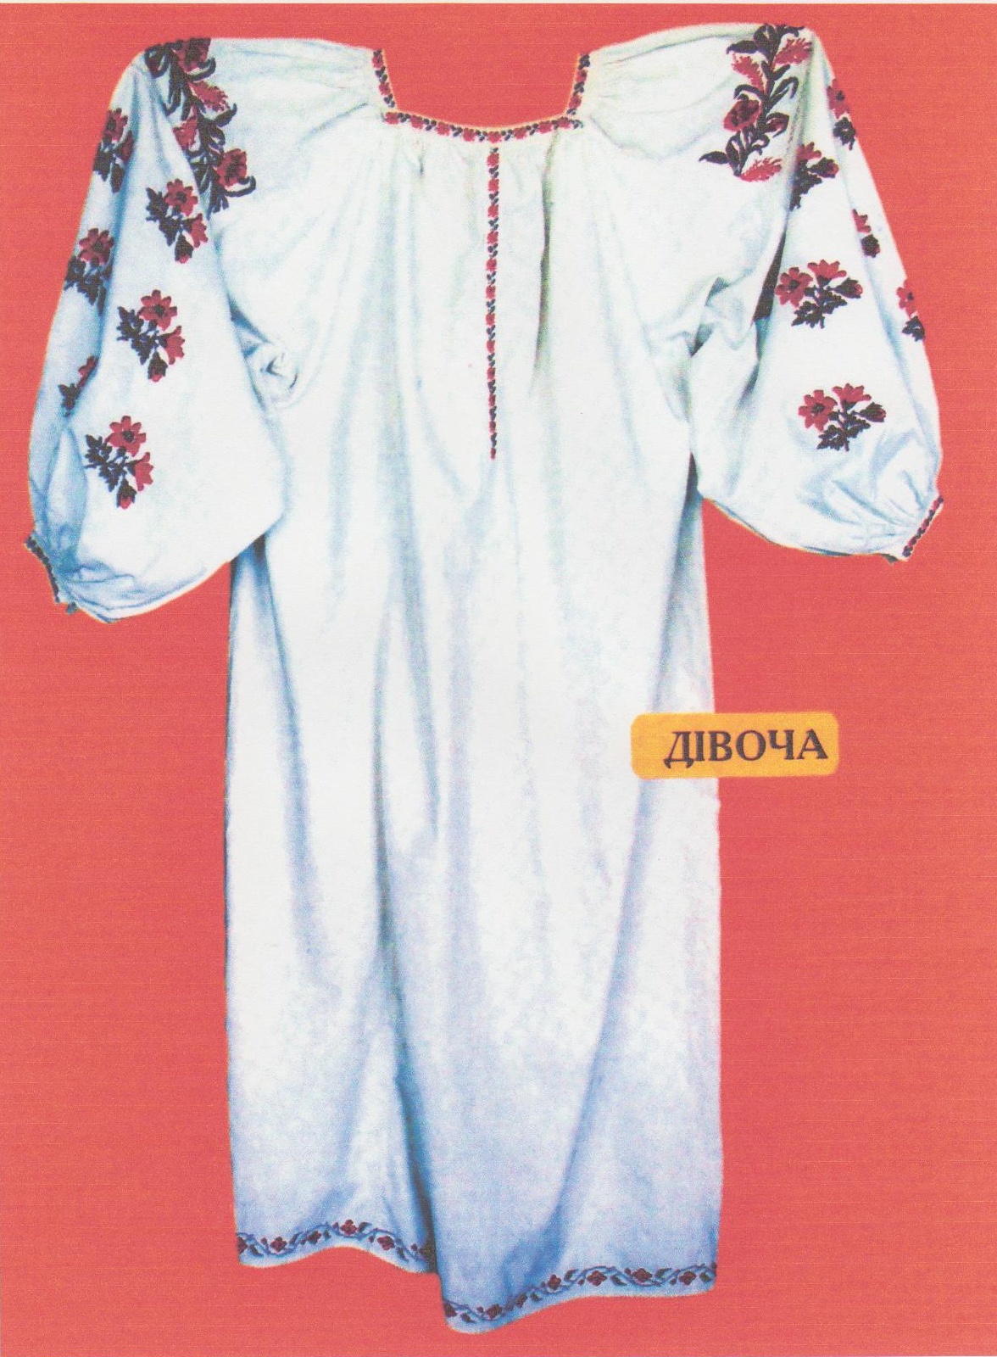
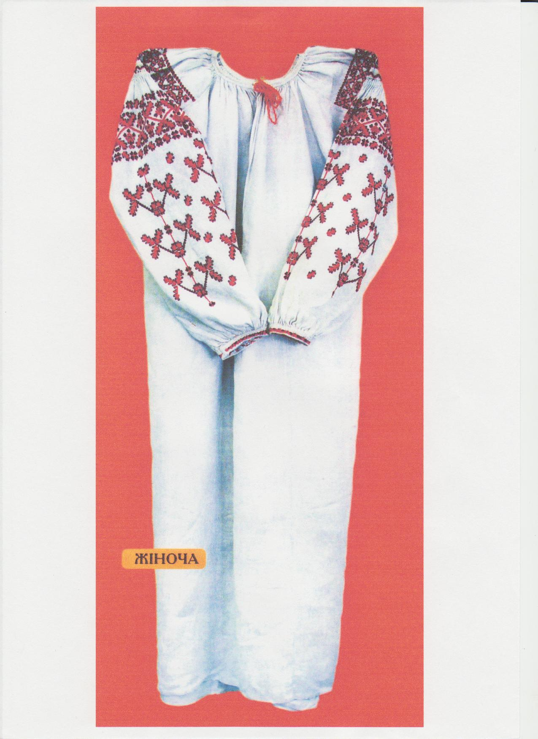
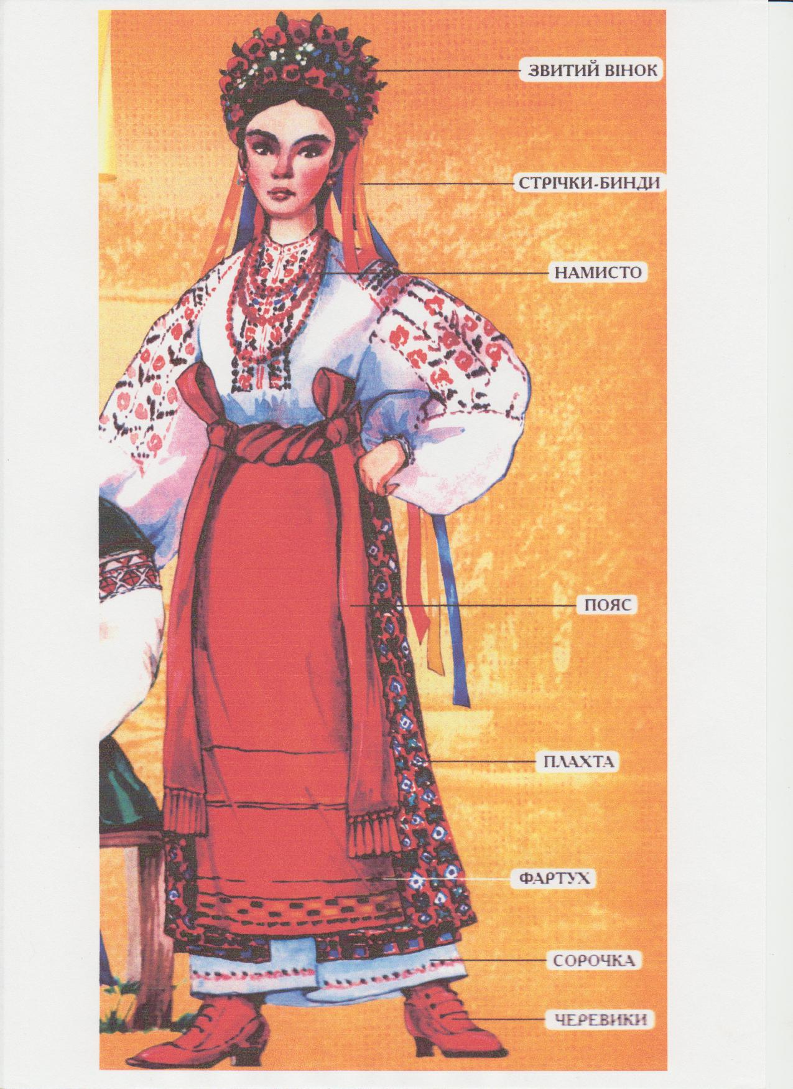

was put on - одягнена
belting - поясний
a piece - шматок
fabric - тканина
wore - носили
apron - фартух
appeared - з’явилася
coins - монети
beads - намисто
adornment - прикраса
skin - шкіра
wool - вовна
soft - м’яка
head - голова
married - заміжня
shoes - туфлі
boots - черевики
consists of - складається з
together - разом
Task 1
Finish the sentences:
1. The women’s blouse is the…..
2. Opynka is an original…..
3. It should be mentioned……
4. Ochipok is a head….
5. Poperednytsya was ……
6. Women wore zapaska …….
7. Plakhta was a checked cloth …..
8. Plakhta consists of ….
9. Spidnytsya (a skirt) …..
10. Dukaty is ….
11. Lychaky was ……
12. Postoly was made ….
13. A blouse was put ….
14. Keptar was decorated by ……

A BRAID IS A GIRL’S BEAUTY
Children as a rule are birthed with short hair. When a child was one year
old his hair was cut. It was a boy. A girl’s hair was not cut. A mother took care of
a girl’s hair. She wanted her hair to be thick and long. In Ukraine mother taught
her daughter to comb hair in the morning. At first when a girl awakened she
had to comb and braid her hair. A girl could not begin working not braiding her
hair. As a rule braids were plaited at 5 years old. That was a tradition. White
ribbons were plaited in braids. There was a chaplet on the head too. People
considered that a braid had to be cut only by one of the relatives – men on a full
Moon. A girl herself had not cut hair. A braid was always a girl’s beauty in
Ukraine. When married, a girl put on an ochipok on the head. The braid was
cut short.
Glossary
As a rule - як правило
Hair - волосся
Cut - стригти
Thick - густе
Comb - розчісувати
Awaken - прокидатися
Could - міг, могла
Braid - коса
Plait - заплітати
Consider - вважати
Relatives - родичі
Moon - Луна
Full - повна

Task 1
Answer the questions:
- What hair are children birthed with?
- When did grown-ups cut a boy’s hair?
- Who took care of a girl’s hair?
- Who taught a girl to comb and plait?
- Why did mother take care of her daughter’s hair?
- When was a braid plaited?
- Who could cut hair and when?
- What is a girl beauty?

Task 2
Try to translate the proverbs:
- Нема коси – нема краси.
- Дівка без коси – що кінь без гриви.
- Де дівка з косою – там хлопці юрбою.
- Не вари борщу, доки не заплетешь косу.
- Косу сбережешь, щастя найдешь.

Task 3
Open the brackets:
- Children as a rule (to be birthed) with short hair. (Present Simple).
- Ukrainians (not cut) a girl’s hair. (Past Simple).
- A girl herself (not cut) hair. (Past Simple).
- Tomorrow I (read) the text about a girl’s beauty. (Future Simple).
- Now I (cut) my hair. (Present Continuous).

THE UKRAINIAN CHAPLET
is not only a decoration, but it is also a guard. To twine a chaplet is a real sci-
ence. Our fore mothers knew when to twine, when to gather flowers for the
chaplet. The girls began to wear chaplets at the age of three. Their mothers
twined chaplets for their three-year old girls. There were forget-me-nots, mari-
golds, periwinkles, chamomiles in them. They said that every flower treated a
child. When a girl was four years old there was another chaplet. There were
immortals and leaves of apple-trees in them too. When the girl was six years
old and seven years old there were other chaplets with different flowers.
There were 12 flowers in the chaplet of a grown-up girl.
Speaking about a chaplet we should ribbons because they were the main
part of a chaplet. There were 21 ribbons in the chaplet.
They were red, light-blue, dark-blue, yellow, green, white. For example, a
yellow ribbon was a symbol of the sun. A light-green ribbon meant beauty and
youth. It must be stressed that the ribbons were a little bit longer than a braid
to hide it. There are many folk proverbs about chaplets. What a chaplet –
such a voice( Який венок - такой голос).
What a yard – such a chaplet (У цьому дворку, як у венку).

GLOSSARY
Decoration - прикраса
Twine - плести
Real - справжня
Science - наука
Knew - знали
How - як
Gather - збирати
It must be stressed - слід підкреслити
Forget-me-nots - незабудки
Marigolds - ногітки
a | b | l | e | a | v | e | s | v | c
x | s | p | e | a | k | i | n | g | h
m | b | e | c | a | u | s | e | b | n
v | m | a | i | n | b | v | c | f | g
d | f | s | u | n | e | r | t | y | t
w | f | o | l | k | b | v | c | v | c
z | p | r | o | v | e | r | b | s | a
r | i | b | b | o | n | d | f | s | x
s | y | m | b | o | l | n | b | y | u
s | d | f | g | a | t | h | e | r | j
c | h | a | p | l | e | t | a | s | d
Periwinkles - барвінок
Chamomiles - ромашки
Immortals - незабудки
Leaves - листя
Grown-up - доросла
Speaking - говорячи
Ribbons - стрічки

Task 1
Find the words:

Task 2 Rearrange the sentences in the correct order:
- There were, in the chaplet, 21 ribbons.
- A yellow ribbon, a symbol, was, of the sun.
- There are, about chaplets, folk, many, proverbs.
- There were, in the chaplet, flowers, many.
- To twine, is a real science, a chaplet.
- The girls, to wear, began, at the age, of three.
- Our foremothers, when, knew, and, how, to twine.
- Their mothers, chaplets, twinned, three-year old girls, for their.
- A light green, meant, ribbon, beauty.
10 It must be stressed, the ribbons, that, were, a little bit longer, a braid, than.
11 What, a chaplet, such, a voice.

UKRAINIAN NATIONAL MEN’S CLOTHES
The main element of the men’s clothes is an embroidered shirt. It was
sewn of white linen. The collar of it was embroidered with grey, black or blue
and red threads. The cuffs were embroidered with another ornament. People
used to say «До Великодня сорочка хоч і лихенька, аби біленька».
In the west regions a shit was put on Sharovary. In the east regions a
shirt was shorter and put under Sharovary. There were two kinds of trousers:
narrow and wide sharovary. Sharovary were always red. Men wore sashes
(belts). They were long. The young men wore red and green sashes. The old
men wore black sashes.
There was a tradition to wear hats and caps. There were fur caps.
In summer men wore straw hats (bryl). Men like women (in the west) wore
keptar. Kuchma is a tall cap made of fur (sheep).

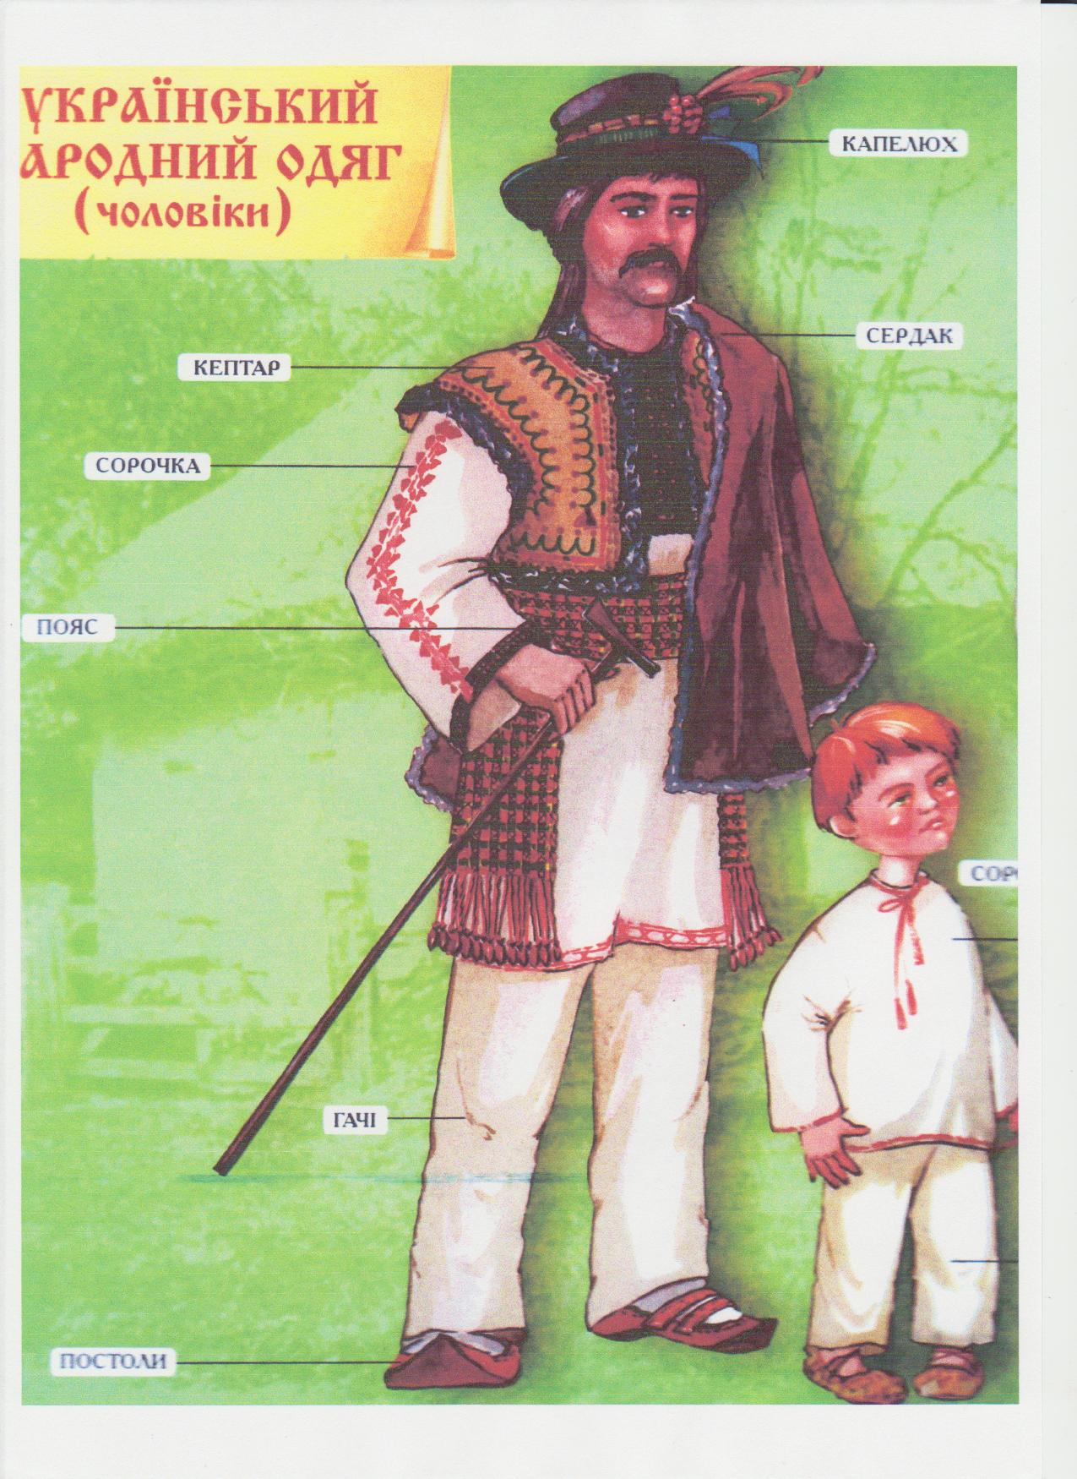
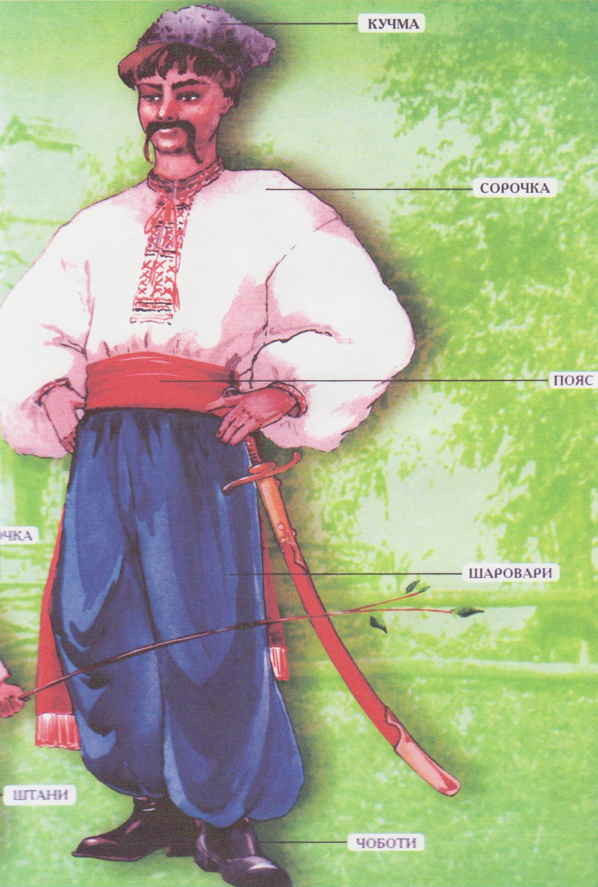
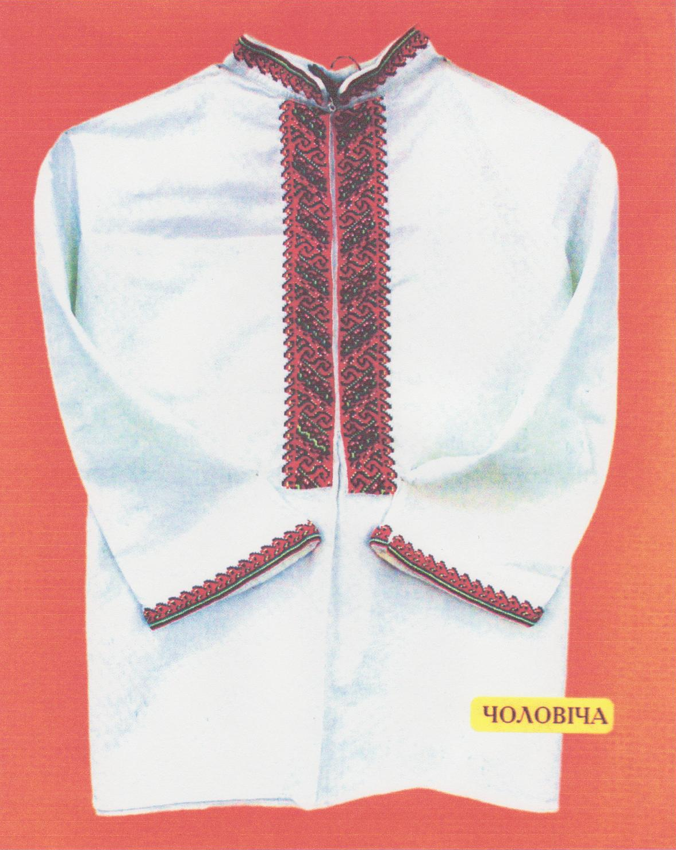
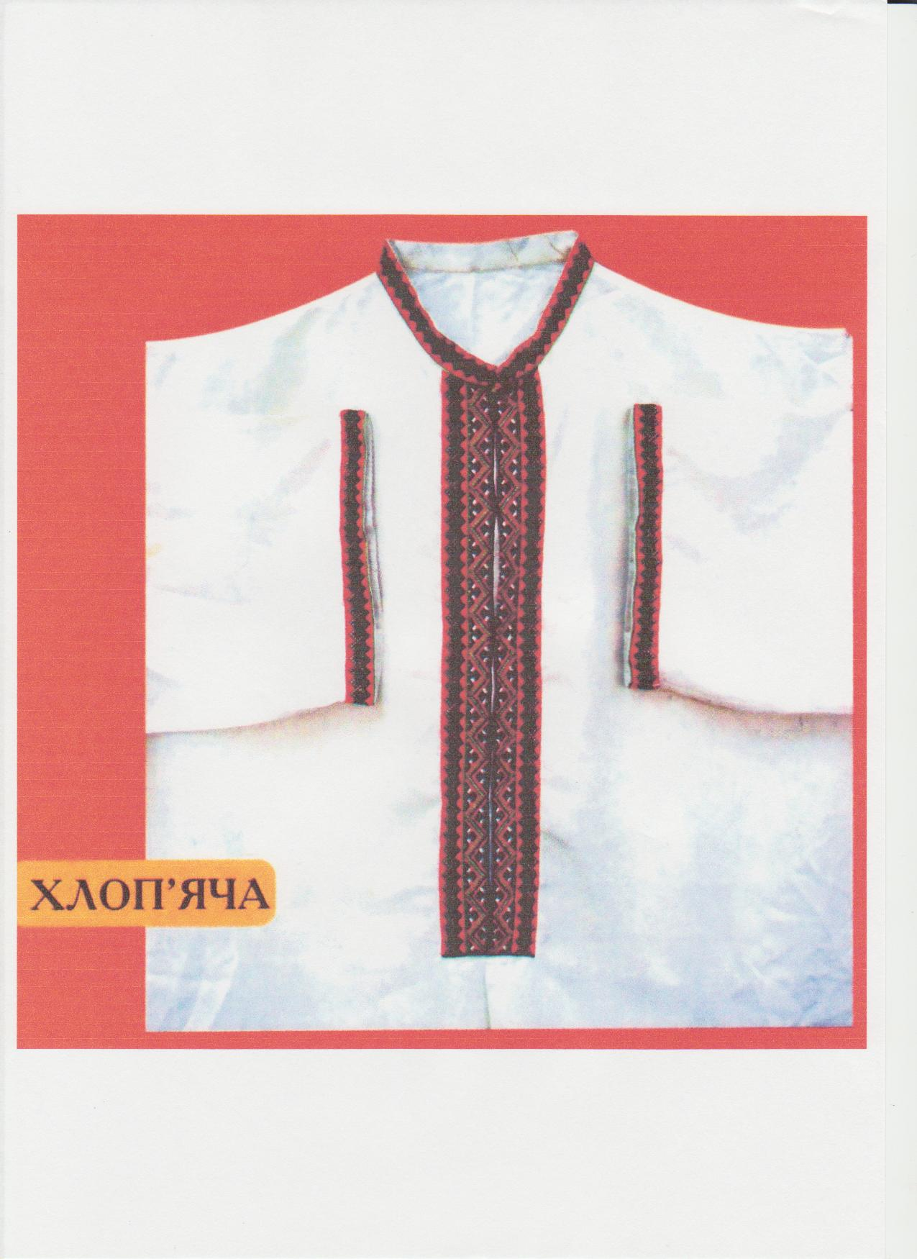
Glossary
Cuffs - манжети
Shorter - коротше
Under - під
Kinds - види
Trousers - штани
Almost - майже
Sashes - пояси
Were - були
Wore - носили

Task 1 FINISH:
- Kuchma is a….. .
- There are two kinds of….. .
- In the west regions a shirt was….. .
- The main element of the men’s clothes…. .
- ……. wore black sharovary.
- …….wore Keptar.
- ……wore red sharovary.
- The collar was….. .

TASK 2

Answer the questions:
- What is the main element of the men’s clothes?
- What was a shirt sewn of?
- The collar was embroidered, wasn’t it?
- How did men wear sharovary and a shirt?
- What color was sharovary?
- Who were red sharovary?
- Who wear Keptar?
- When did men wear Kuchma-cap?

Task 3
Open the brackets:
- The main element of the men’s clothes (to be) an embroidered
Shirt (present simple)
- There (to be) two kinds of trousers (past simple).
- The young men (to wear) red sharovary (past simple).
- I (to read) about sharovary (present perfect).
- Now I (to read) about clothes (present continuous).
- Tomorrow we (to put) questions to the text (future simple).
- There (to be) a tradition to wear hats and caps (present simple).
- By 6 o’ clock my father (to wear) Ukrainian clothes (past perfect).

Task 4

k | u | c | h | m | a | v | b
x | g | w | e | a | r | i | o
s | h | a | r | o | v | a | r
y | f | g | h | h | h | a | t
s | h | i | r | t | b | n | m
e | l | e | m | e | n | t | s
c | o | l | l | a | r | g | h
k | e | p | t | a | r | y | u

EASTER
WHAT SYMBOL IS PYSANKA?
WHAT HOLIDAY IS IT A SYMBOL OF?

Easter is the most important holiday of the year. It is interesting that there is no fixed date of this holiday. Our forefathers celebrated it according to the Moon calendar on the first Sunday after the first spring full Moon.
It is on Sunday between the 4th of April and the 8th of May. The week before Easter is called Pure Week. People clean their houses.
The last Sunday before Easter is called Willow Sunday. On this holiday pussy willow branches are blessed in the churches.
People tap one another with the branches repeating the wish
«Be as tall as the willow, as healthy as water and rich as the earth.
Not I am tapping, the willow is tapping, and Easter is in a week”.
On Easter people go to the church to bless their food: bread, Pasky, sausages, meat, fiber, Krashanky, cheese and other provisions.
People say “Christ has risen” and kiss each other three times.

NATIONAI FOOD
The analysis of the laboratory «About national peculiarities of food”.
The everyday food of Ukrainians was the products of plant and animal origin. The widest products were maize, millet, buckwheat, beans, barley. The Ukrainians cooked porridge. Porridge was like bread. Another bread was potatoes.
Among vegetables there were: cucumbers, tomatoes, melons, pumpkins, musk-melons. The Ukrainians ate berries and fruits: cherries, apples, pears, plums. They baked bread. The traditional food was borsch, galushki, varenyky. The Ukrainians did not eat, there were Christian’s posts. They ate 3 or 4 times a day: breakfast, dinner, supper. People gathered mushrooms. They ate onions, garlic in order to be healthy.

TASK: CIRCLE THE LETTER OF THE BEST ANSWER:

- The laboratory analyzed…..
- Food;
- Ukrainian food;
- Products;
- Bread.
- The Ukrainians ate….
- Bread, porridge;
- Soups;
- Plums.
- They ate….
- 3 times a day;
- 3 or 4 times a day;
- 5 times a day.

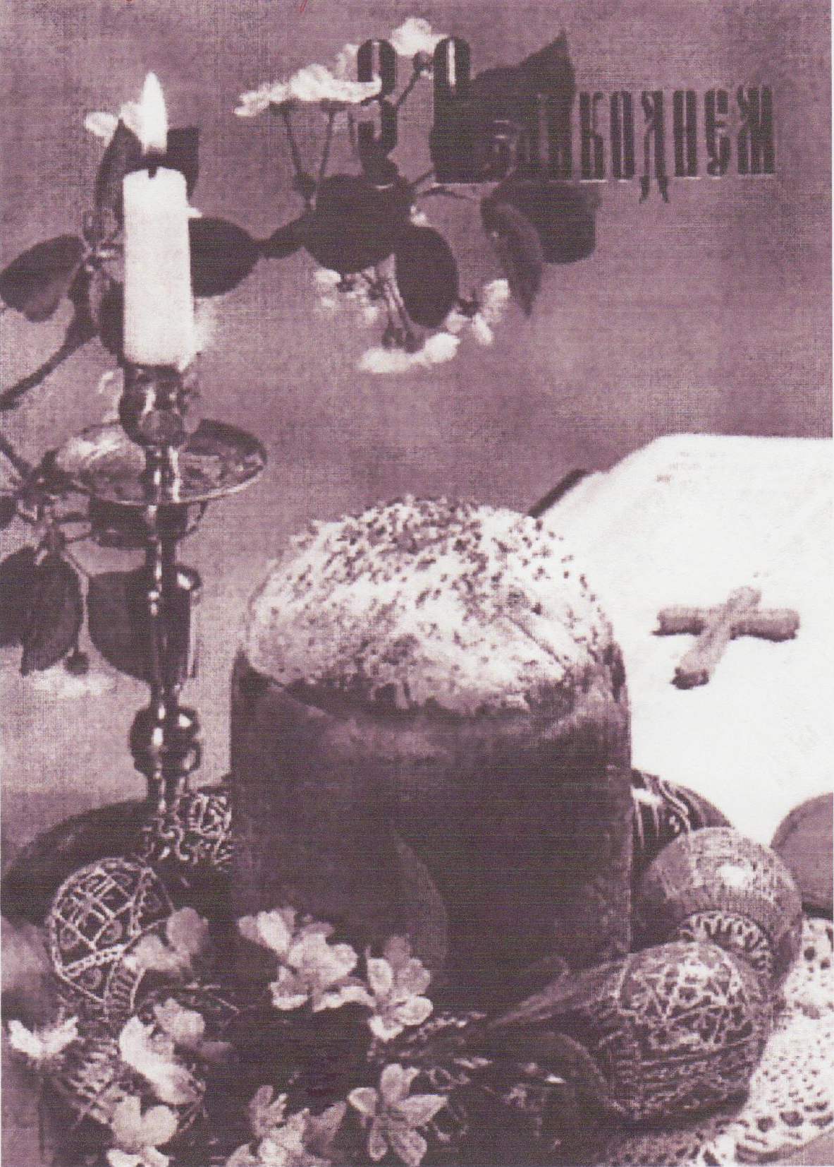
NAME THE PRODUCTS:
